TOWN OF PIERSON COMPREHENSIVE PLAN 2040

FUTURE LAND USE ELEMENT GOALS, OBJECTIVES AND POLICIES

FLU Goal I: Manage and Plan Growth/Development. The growth and development of Pierson shall be managed consistent with the need to promote economic benefit and enjoyment of natural and man-made resources by the citizenry, while minimizing hazards and nuisances of incompatible land uses, overcrowding, and degradation of the environment.

FLU Objective I-1: Compliance with Comprehensive Plan Mandated. No use or development of land shall occur in Pierson except in conformance with adopted Future Land Use Plan.

FLU Policy I-1.1: Ensuring Compliance with Comprehensive Plan. The Town’s zoning and subdivision regulations and other land use and development regulations shall be utilized as a means of ensuring conformance with the Future Land Use Plan.

FLU Policy I-1.2: Land Use, Density and Intensity. The use and density or intensity of development permitted in each of the land use categories indicated on the Town’s Future Land Use Map shall be consistent with the following standards:

- Agriculture and Rural Residential Use. Areas identified for Agriculture and Rural Residential Use are suitable for rural residential uses and agricultural and agricultural and horticultural activities including silviculture cattle grazing, keeping of livestock, cultivation of crops, cultivation of ornamental plants, dairies and those commercial or other uses on a limited scale serving or ancillary to agricultural activities, such as farm equipment and supplies, sale or service, and agricultural products distribution. The number of single family dwelling units shall not exceed 1 per five (5) acres.

- Low Density Residential Use. This category permits single family dwellings and uses and structures which are customarily associated with and incidental to residential development. The number of single family dwelling units shall not be more than 1 per acre.

- Medium Density Residential Use. This category permits single family dwellings and uses and structures which are customarily associated with and incidental to residential development. The number single family dwelling units shall not be more than 3 per acre.

- Medium Density Mobile Home Use. This category permits mobile homes, manufactured homes and uses which are customarily associated with and incidental to residential development. The number of mobile homes and manufactured homes shall not be more than 3 units per acre.

- High Density Residential Use. This category permits various types of dwellings and uses which are customarily associated with and incidental to residential development. The number of dwelling units shall not be more than 4 dwelling units per acre but less than 10 (ten) per acre.

- General Retail Commercial Use. Areas so designated on the Town’s Future Land Use Plan Map are intended to provide for business, retail, service, office and other commercial enterprises which support the resident and transient populations of the Town and surrounding area.

This land use category is most appropriately applied to central areas of the Town. The following uses are permitted within the General Retail Commercial Land Use category:

  - Retail sales and services;
  - Office and business uses;
  - Hotels, motels and similar lodging;
  - Parks, recreation, open space and commercial recreation;
  - Community facilities; and
  - Utilities, transportation and communication facilities;

The ratio of building floor area to total site area shall not exceed 0.50. (The ratio is calculated by dividing the building floor area by the site area.)

- General Retail Commercial Use (Low Intensity). Areas so designated on the Town’s Future Land Use Map are intended to provide for business, retail service, office and other commercial enterprises which support the resident and transient populations of the Town and surrounding area at relatively low intensity. This land use category is most appropriately applied outside the central areas of the Town. The following uses are permitted with the General Retail Commercial Land Use (Low Intensity) category:

  - Retail sales and services;
  - Office and business uses;
  - Hotels, motels, and similar lodging;
  - Parks, recreation, open space and commercial recreation;
  - Community facilities; and
  - Utilities, transportation and communication facilities.

The ratio of building floor area to total site area shall not exceed 0.35. (The ratio is calculated by dividing the building floor area by the site area.)

- Heavy Commercial and Industrial Use. Areas so designated on the Town’s Future Land Use Plan Map are intended to provide for wholesale storage; sales and distribution of goods and materials; manufacturing and assembly activities; transportation, utilities and communications; and retail sales and services involving storage, sale and servicing of heavy goods, materials and equipment. The ratio of building floor area to total site area shall not exceed 0.60.

- Public/Institutional Use. Areas designated as Public/Institutional permit uses that serve the educational, health and social needs of the community and shall include, but shall not necessarily be limited to, the following:

  - Educational facilities such as elementary and secondary schools, both public and private;
  - Places of worship, monasteries and convents;
  - Hospitals and other public health care and social service facilities
  - Nursing homes and homes for the aged;
  - Cemeteries;
  - Municipal, state and federal buildings;
  - Libraries, community and recreational centers, parks, fire and police stations; and
  - Publicly owned and operated transportation facilities, including transit stations, park-and-ride facilities and airports.

Private medical clinics and group homes shall not be considered as institutional uses. The ratio of building floor area to total site area shall not exceed 0.60.
- Agriculture shall be permitted in all land use categories.

- Recreation Land. Areas so designated are intended to provide for parks, recreation facilities and open spaces which serve public recreation needs and/or protect and conserve natural functions of land and water areas. Impervious surface parcels coverage shall be limited to fifty percent (50%) of the total parcel area for user-oriented recreational sites and five percent (5%) for passive recreational sites.

- Conservation. Future development and redevelopment activities shall be directed away from areas depicted on the Future Land Use Map as “Conservation” where such activities are not compatible with the extreme soil wetness or instability, high potential for flooding, wetlands, and suitability for habitat of threatened or endangered species known to inhabit the area. Publicly owned lands that lie within the Conservation land use category are limited to resource-based, passive recreation and open space uses such as walkways,

piers, and docks elevated on pilings. On privately owned lands designated by the Future Land Use Map as Conservation, the density shall be limited to single family residences not exceeding one (1) dwelling per twenty (20 acres).
Clustering of structures on the upland portions of building sites shall be required; a minimum 25-foot buffer adjacent to wetlands and water bodies shall be required; and the native vegetation shall be maintained within the wetlands and buffers as undisturbed open space.

FLU Policy I-1.3: School Planning Coordination and Consistency. Consistent with Public School Facility Element the Town of Pierson shall continue to coordinate with the Volusia County School Board in locating future school sites and in the commitment of sites during the development approval process through interlocal agreements and through other means deemed appropriate.

FLU Policy I-1.4: School Siting and Future Land Use Map Designations Accommodating Public Schools. Schools shall be permitted in all future land use classifications except for the Heavy Commercial and Industrial Use, Conservation and Recreation Future Land Use.

Future Land Use Designations Schools Permitted or Not Permitted
Agriculture and Rural Residential Schools Permitted Low Density Residential Schools Permitted
Medium Density Residential Schools Permitted
High Density Residential Schools Permitted
Public/Institutional Schools Permitted
General Retail Commercial Schools Permitted General Retail Commercial (Low Intensity) Schools Permitted Heavy Commercial & Industrial Schools Not Permitted Conservation Schools Not Permitted
Recreation Land Schools Not Permitted

FLU Policy I-1.5: Location, Acquisition, Phasing and Development of Future School Sites and Ancillary Facilities. Consistent with Public School Facility Element, coordination of the location, acquisition, phasing and development of future school sites and ancillary facilities shall be accomplished through the procedures adopted in the interlocal agreement. Proposed school sites shall be located away from industrial uses, railroads, and similar land uses to avoid noise, odor, dust and hazards.

FLU Policy I-1.6: Avoidance of Incompatible Land Use and School District Participation in Review of Proposed Development Adjacent to Schools. Consistent with Public School Facility Element, the Town of Pierson shall protect schools and land banked school sites from the adverse impact of incompatible land uses by providing the School District with the opportunity to participate in

the review process for all proposed development adjacent to schools. In order to minimize potential adverse impacts resulting from traffic and school yard noise, proposed school sites shall be located away from, or shall be buffered from, hospitals, adult communities, nursing homes, and similar uses.

FLU Policy I-1.7: Joint Coordination, Planning and Written Agreements for On and Off-Site Improvements to Serve New School Projects. Consistent with Public School Facility Element, the Town of Pierson and School Board will jointly determine the need for and timing of on-site and off-site improvements necessary to support each new school or the proposed renovation, expansion, or closure of an existing school. If deemed necessary, the parties may enter into a written agreement as to the timing, location, and party or parties responsible for constructing, operating, and maintaining the required improvements. School sites shall be located within areas served by requisite public facilities and such sites shall promote compact growth. The Town shall implement the following policy components:

  - Acquisition and Use of Land Banked Sites for School Facilities Serviced In Advance with Adequate Infrastructure. The Town of Pierson shall encourage the School Board to land bank sites for future use as school facilities. The Town of Pierson shall coordinate with the School Board on the acquisition and use of land banked sites in the same manner as established for other sites in order to ensure adequate infrastructure is planned and constructed in advance of school construction.

  - Infrastructure Planning to Service Schools and Land Banked School Sites. In developing capital improvements plans and programs for public services, the Town of Pierson shall consider required infrastructure to service existing and proposed schools and any land banked school sites.

FLU Policy I-1.8: Centrally Locate School Sites in Intended Attendance Zones; Exceptions. Proposed school sites shall be centrally located within their intended attendance zones, to the extent possible. An exception to this central location policy may be allowed for high schools because the large land area they require is usually not available at preferred locations.

FLU Policy I-1.9: School Location Criteria to Ensure Sufficiently Large School Site Size. Proposed school sites shall be sufficiently large to ensure that buildings, ancillary facilities, and future expansions can be located away from flood plains, flood prone areas, wetlands, and other environmentally hazardous areas, and will not interfere with historic or archaeological resources.

FLU Policy I-1.10: Enhance Community Design and School Accessibility by Coordinating Planning for Expansion and Rehabilitation of Existing Schools.

In order to enhance community and neighborhood design through effective school facility design and siting standards and to encourage the location and design of school facilities that serve as community focal points and are compatible with surrounding land uses, the Town of Pierson shall coordinate with the School Board on opportunities for planned expansion and rehabilitation of existing schools and application of enhanced design of neighborhood improvements and redevelopment, For instance, proposed school sites shall be reasonably accessible without creating or contributing significant hazards for pedestrians, bicyclists, and motorists.

FLU Policy I-1.11: Reduce Hazardous Walking Conditions. The Town of Pierson shall reduce hazardous walking conditions consistent with Florida’s safe ways to school program. In conjunction with the School Board, the Town of Pierson shall implement the following strategies:

    - New developments adjacent to schools shall be required to provide a right-of-way and direct safe access path for pedestrian travel to existing and planned schools and shall connect to the neighborhood’s pedestrian network.

    - In order to ensure continuous pedestrian access to public schools, the Town of Pierson shall consider infill sidewalk and bicycle projects connecting networks serving schools as may be available.

Policy I-1.12: Emergency Shelters as a Component of New, Expanded or Rehabilitated School Facilities. The Town of Pierson and the School Board shall coordinate with Volusia County Emergency Services on efforts to build new school facilities, and facility rehabilitation and expansion, to be designed to serve as and provide emergency shelters as required by Section 1013.372, Florida Statutes.

Policy I-1.13: Opportunities to Co-Locate and Share the Use of Public Facilities. The Town of Pierson shall look for opportunities to co-locate and share the use of public facilities when preparing updates to the comprehensive plan’s schedule of capital improvements and when planning and designing new or renovating existing, community facilities. Co-located facilities shall be governed by a written agreement between the School Board and the Town of Pierson specifying operating procedures and maintenance and operating responsibilities

Policy I-1.14: Collaboration with School Board on Public Facilities Near Public Schools. The Town of Pierson shall collaborate with the School Board on the siting of public facilities such as parks, libraries, and

community centers near existing or planned public schools, to the extent feasible.

Policy I-1.15: Coordinate Comprehensive Plan Amendment and Development Orders with School Capacity. The Town shall manage the timing of new development to coordinate with adequate school capacity.

Objective I-2: Implementing the Comprehensive Plan and Adopted Future Land Use Map. The Town shall continue to enforce its Uniform Land Development Regulations (ULDR) to provide the specific and detailed provisions necessary to implement the Comprehensive Pan and to comply with the requirements of Section 163.3202, F.S., including implementation of the Future Land Use Map Series hereby incorporated into the Future Land Use Element Goals, Objectives and Policies.

FLU Policy I-2.1: Promote Land Use Pattern Consistent with Future Land Use Map. The Town shall use the ULDR to promote the pattern of land use and development expressed by the Town’s adopted Future Land Use Map.

FLU Policy I-2.2: Regulatory Measures Must Mandate Density and Intensity Consistent with Policy I-1.2. The Town shall continue to ensure that the ULDR are consistent with the density and intensity standards indicated in Policy II-1.2 above.

FLU Policy I-2.3: Maintain Performance Standards. The Town shall continue to enforce the
ULDR performance standards for:

- Maintaining adequate buffers and transitions between potentially incompatible land uses;
- Preserving open space and protecting trees and other significant vegetation;
- Promoting safety and security with appropriate building setbacks, orientation, lighting and access;
- Protecting significant historic and archaeological sites and structures; and
- Protecting public potable water supply wells from contamination.

FLU Policy I-2.4: Criteria for Subdivision of Land. The Town shall continue to enforce the
ULDR provisions that ensure that the subdivision of land results in lots that are:

- Adequately sized for the intended use;
- Safely and conveniently accessible from the public road network;
- Provided with adequate potable water, sanitary sewer, and stormwater management facilities; and
- Arranged to minimize potential conflicts with nearby incompatible uses or to promote interaction with nearby compatible uses, if appropriate.

FLU Policy I-2.5: Plan to Avoid Incompatible Uses. In order to minimize land use conflicts, the use of a street, particularly a local street, as a boundary line between residential and commercial land uses shall be avoided. Whenever possible, a rear property line or physical barrier such as a railroad or canal shall be used as a barrier between such potentially incompatible uses.

FLU Policy I-2.6: Criteria for Planning New Residential Development and Traffic Circulation. Access to and traffic circulation within new residential developments shall be arranged to promote social interaction with other residential areas, and to facilitate convenient access to nearby commercial and recreational locations without encouraging commercial traffic to flow through such residential areas.

FLU Policy I-2.7: Discourage Commercial Traffic in Residential Areas. Access to and traffic circulation within new commercial developments shall be arranged to discourage the flow of commercial traffic through nearby residential developments.

FLU Policy I-2.8: Manage Signage to Prevent Visual Disarray and Clutter while Promoting
Business. The Town shall continue to enforce the ULDR sign provisions to ensure that new and replacement signs shall adhere to the community standard for aesthetics and minimize confusion that results from visual disarray, while allowing reasonable identification and promotion of businesses.

FLU Policy I-2.9: Ensure Effective On-site Stormwater Management. The Town shall continue to enforce the ULDR provisions that ensure that new development and redevelopment will provide on-site stormwater management consistent with the objectives and policies of the Drainage Sub-element.

FLU Policy I-2.10: Appearance; Landscaped Open Space; Incompatible Uses; Prevent
Overcrowding and Fire Hazards. The Town shall continue to enforce the ULDR provisions that ensure that new development and redevelopment will provide landscaped open space as needed to minimize conflicts between incompatible uses, to prevent overcrowding, to reduce the potential for the spread of fire, to maintain air circulation, and to promote an attractive, open community appearance.

FLU Policy I-2.11: On-site Parking and Traffic Circulation. The Town shall continue to enforce the ULDR provisions that ensure that new development and redevelopment will provide adequate on-site vehicular parking and safe and convenient on-site traffic circulation.

FLU Objective I-3: Non-Conforming Uses. Existing uses which do not conform to the Future Land Use Plan shall be eliminated by attrition or brought into conformance.

FLU Policy I-3.1: List and Describe Non-conforming Uses and Structures. The Town shall compile a list and description of all existing uses and structures that do not conform to the Future Land Use Plan.

FLU Policy I-3.2: No Expansion of Non-Conforming Uses. No development permits shall be
issued by the Town allowing the expansion of a non-conforming use.

FLU Policy I-3.3: Criteria for Regulating Non-Conforming Uses upon Destruction. If destroyed, a non-conforming use shall not be re-established. A structure shall be deemed to be “destroyed” if, by act of man or nature, its value is reduced more than fifty (50) percent of its assessed value on the latest Volusia County tax roll.

FLU Objective I-4: Criteria for Locating Future Land Uses Near Areas Designated “Conservation”. Future development and redevelopment activities shall be directed away from areas depicted on the Future Land Use Map as Conservation where such activities are not compatible with the extreme soil wetness or instability, high potential for flooding, wetlands, and suitability for habitat of threatened or endangered species known to inhabit the area.

FLU Policy I-4.1: Limitation on Use of Publicly Owned Land in Areas Designated “Conservation”. Publicly owned lands that lie within the Conservation land use category are limited to resource-based, passive recreation and open space uses such as walkways, piers, and docks elevated on pilings.

FLU Policy I-4.2: Limitation on Use and Density of Privately Owned Land in Areas Designated “Conservation”. On privately owned lands designated by the Future Land Use Map as Conservation, the density shall be limited to single family residences not exceeding one (1) dwelling per twenty (20 acres).

FLU Policy I-4.3: Buffer Restriction Adjacent to Wetlands and Water Bodies. Clustering of structures on the upland portions of building sites shall be required; a minimum 25-foot buffer adjacent to wetlands and water bodies shall be required; and the native vegetation shall be maintained within the wetlands and buffers as undisturbed open space.

FLU Policy I-4.4: Policy Applicable to Privately Owned Wetland Lots with Insufficient
Adjacent Upland to Permit Use without Encroaching Wetland. For privately owned lots of record on August 27, 1991 that lie entirely within wetlands or do not contain sufficient uplands to permit use of the property without development in the wetlands, then the amount of development is limited to the minimum amount necessary to permit construction of a dwelling on pilings. The Town may vary setback requirements to allow transfer of the density from the wetlands to the

upland portion of the site; however, when setback reductions cannot accommodate the location of the dwelling, compensatory mitigation of wetland shall be required.

FLU Policy I-4.5: Restrictions on Toxic and Hazardous Materials in Areas Designated Conservation. Land uses requiring the generation, use or storage of toxic or hazardous materials or waste shall be prohibited in the Conservation land use category (and within any other wetland).

FLU Objective I-5: Restrictions on Silviculture Activities to Protect Wetlands and Surface Waters. Silviculture activities may be undertaken on privately owned lands and are to be conducted in a manner compatible with the need to protect and conserve natural resources associated with wetlands and surface waters.

FLU Policy I-5.1: Silviculture Operations to Maintain Consistency with Best Management Practices. Silviculture operations shall adhere to accepted Best Management Practices (BMP's) for wetlands protection, surface water management and erosion control.

FLU Objective I-6: Development Limitation to Maintain Level of Service Standards. Limit development as necessary to maintain the level of service standards adopted as part of the Capital Improvements Element of the Town’s Comprehensive Plan.

FLU Policy I-6.1: Concurrency and Availability of Public Services. The Town shall ensure that public facilities and services will be available concurrent with the impacts of development, or that development orders and permits are specifically conditioned on the availability of facilities and services necessary to serve the proposed development at the adopted level of service standard.

FLU Policy I-6.2: Concurrency Management Program. The Town shall continue to enforce Article IV, ULDR, Consistency and Concurrency Determinations, of their ULDR, that establishes detailed procedures, guidelines and accountability for ensuring that the adopted level of service standards will be maintained.

FLU Objective I-7: Protection of Historic Sites and Structures. Any historic sites and structures that may be officially recognized by the Town, the State or federal government as historically significant shall be protected from encroachment by incompatible land use activities.

FLU Policy I-7.1: Eligibility for the National Register of Historic Places. The Town shall ensure that all historical sites and structures eligible for inclusion on the National Register of Historic Places will be submitted to the US Department of the Interior for inclusion on the Register.

FLU Policy I-7.2: Priority Given to Adaptive Re-Use of Historic Structures. Adaptive re-use of historic structures in a manner that will preserve the historic value of such

structures shall be given priority over re-use and redevelopment that would reduce their historic value.

FLU Policy I-7.3: Voluntary Assistance from Available Historians and Archaeologists. The Town shall continue, with voluntary assistance from historians and archaeologists as may be available, to identify significant historic sites and structures.

FLU Objective I-8: Ensure Availability of Suitable Land for Necessary Utility Facilities. The Town shall ensure the availability of suitable land for utility facilities necessary to support existing and future development as outlined by the Future Land Use Element.

FLU Policy I-8.1: Require Dedication of Adequate Land Area in New Developments for Needed Public Facilities. The Town shall continue to enforce its Uniform Land Development Regulations which require dedication of adequate land area in new developments for the provision and maintenance of utility facilities needed to serve such developments.

FLU Policy I-8.2: Allow Essential Utilities and Structures as Permitted Uses. The Town shall continue to enforce its Uniform Land Development Regulations which allow essential utility uses and structures as permitted uses throughout the Town. Essential utility uses and structures shall be defined as publicly owned or regulated utility distribution systems for gas, water, sewer, telephone, television, radio or electricity of 230 kilovolts or less including poles, wires, mains, drains, sewers, pipes, conduits, cable towers, and antennas 70 feet or less in height, and other similar equipment and accessories which are necessary for furnishing of service by such public utilities, but not including electric power plants, substations, water tanks, gas transfer station, and water and sewage treatment plants, buildings, and municipal water supply wells.

FLU Policy I-8.3: Future Utility Needs and Required Consideration in Comprehensive Plan.
Upon notification by any public or private utility company of a need for a site for any utility facility intended to provide service to the residents or businesses of Pierson, the Town shall include consideration of such facility in the Comprehensive Plan.

FLU Objective I-9: Pierson Airport to Continue as a Public General Use Aviation Facility. The Town shall operate and maintain the Pierson Airport as a general use aviation facility, open to the public.

FLU Policy I-9.1: Restrict and Control Airport Access to Promote Safety and Security. Access to and within the airport property shall be restricted and controlled to promote safety and security. Direct access from adjoining private property shall be prohibited.

FLU Policy I-9.2: Limit Uses and Structures on Airport Property. Land uses and structures on airport property shall be limited to those that are customarily associated with and related to general aviation.

FLU Objective I -10: Annexation Agreement to Sustain Agricultural Industry, Compatible Economic Development, and Job Creation within Pierson. Establish an Intergovernmental Agreement with Volusia County to achieve opportunities for annexation supportive to continued preservation and development of the Town’s agricultural industry, diversification of the town’s economic base, to retain a labor force and promote job creation within Pierson as elaborated in the following policy.

FLU Policy I -10.1: Implement Annexation Agreement that Assists in Sustaining the Town’s Economic Development and Promotes Retention and Expansion of Job Opportunities. In coordination with Volusia County, the Town shall develop a memorandum of understanding, interlocal agreement, or other mutually acceptable formal mechanism that includes future land use and intergovernmental coordination objectives and policies for establishing an annexation boundary agreement, including guidelines, principles, strategies, and criteria for accommodating future land use needs supportive to the Town’s agricultural industry, diversification of the Town’s economic base, retention of the Town’s labor force, and promotes job creation within the Town of Pierson in an energy efficient manner. The intent is to promote rural land stewardship, protect and allow diversification of viable agriculture operations and related activities within the Town over the long-term, while generating jobs not solely dependent upon, but compatible with and complement existing agricultural operations. The intent is to encourage creation and expansion of industries that use agricultural products in innovative ways and to accomplish such actions in a manner that does not promote urban sprawl and fosters shorter travel distances from home to work and promote energy efficiency.

FLU Objective I-11: Avoidance of Urban Sprawl. The future land use element and any amendment to the future land use element shall discourage the proliferation of urban sprawl by applying the implementing the following considerations in rendering action on regarding amendments to the Comprehensive Plan Future Land Use Element.

FLU Policy I-11.1: Criteria Governing Determinations of Urban Sprawl. The primary indicators that a plan or plan amendment does not discourage the proliferation of urban sprawl are listed below.
  - The evaluation of the presence of these indicators shall consist of an analysis of the plan or plan amendment within the context of features and characteristics unique to each locality in order to determine whether the plan or plan amendment:

    - Promotes, allows, or designates for development substantial areas of the jurisdiction to develop as low-intensity, low-density, or single-use development or uses.
    - Promotes, allows, or designates significant amounts of urban development to occur in rural areas at substantial distances from existing urban areas while not using undeveloped lands that are available and suitable for development.
    - Promotes, allows, or designates urban development in radial, strip, isolated, or ribbon patterns generally emanating from existing urban developments.
    - Fails to adequately protect and conserve natural resources, such as wetlands, floodplains, native vegetation, environmentally sensitive areas, natural groundwater aquifer recharge areas, lakes, rivers, shorelines, beaches, bays, estuarine systems, and other significant natural systems.
    - Fails to adequately protect adjacent agricultural areas and activities, including silviculture, active agricultural and silvicultural activities, passive agricultural activities, and dormant, unique, and prime farmlands and soils.
    - Fails to maximize use of existing public facilities and services.
    - Fails to maximize use of future public facilities and services.
    - Allows for land use patterns or timing which disproportionately increase the cost in time, money, and energy of providing and maintaining facilities and services, including roads, potable water, sanitary sewer, stormwater management, law enforcement, education, health care, fire and emergency response, and general government.
    - Fails to provide a clear separation between rural and urban uses.
    - Discourages or inhibits infill development or the redevelopment of existing neighborhoods and communities.
    - Fails to encourage a functional mix of uses.
    - Results in poor accessibility among linked or related land uses.
    - Results in the loss of significant amounts of functional open space.
  - The future land use element or plan amendment shall be determined to discourage the proliferation of urban sprawl if it incorporates a development pattern or urban form that achieves four or more of the following:
    - Directs or locates economic growth and associated land development to geographic areas of the community in a manner that does not have an adverse impact on and protects natural resources and ecosystems.
    - Promotes the efficient and cost-effective provision or extension of public infrastructure and services.

    - Promotes walkable and connected communities and provides for compact development and a mix of uses at densities and intensities that will support a range of housing choices and a multimodal transportation system, including pedestrian, bicycle, and transit, if available.
    - Promotes conservation of water and energy.
    - Preserves agricultural areas and activities, including silviculture, and dormant, unique, and prime farmlands and soils.
    - Preserves open space and natural lands and provides for public open space and recreation needs.
    - Creates a balance of land uses based upon demands of residential population for the nonresidential needs of an area.
    - Provides uses, densities, and intensities of use and urban form that would remediate an existing or planned development pattern in the vicinity that constitutes sprawl or if it provides for an innovative development pattern such as transit-oriented developments or new towns as defined in s. 163.3164.

FLU Objective I -12: Ensure Adequate Potable Water Supply and Quality Consistent with Existing and Future Population Demands. In order to meet the goal of providing adequate quantity and quality of potable water to meet the demands of the present and future population for consumption and other purposes, no use or development of land shall occur in Pierson unless adequate water system capacity is available or will be available when needed to serve the development.

FLU Policy I -1.12.1: Potable Water Level of Service. A level of service standard of 56 gallons per capita per day (total demand for all users/current population) is hereby adopted and shall serve as the basis for determining the availability of adequate water system capacity.

FLU Policy I -12.2: Regulatory Measures to Ensure Availability of Adequate Water Supply. The Town shall not issue development orders or development permits without first determining whether adequate water supplies to serve the development will be available no later than the anticipated date of issuance by the Town of a certificate of occupancy per the Town’s potable water concurrency system of its Land Development Regulations.

FLU Policy I -12.3: Potable Water Interlocal Agreement with Volusia County. The Town, in accordance with the Volusia County Comprehensive Plan, shall enter into an interlocal agreement with the county for those portions of its potable water service area outside the Town’s corporate limits.

FLU Objective I-13: Five-Year Schedule of Capital Improvement Needs and Annual Update.
The Town shall maintain a five-year schedule of capital improvement needs for public

facilities, to be updated annually in conformance with the review process for the Capital Improvements Element of this Plan.

FLU Policy I-13.1: Implementing Projects in Capital Improvement Program. Potable water facility projects shall be undertaken consistent with the Plan’s Capital Improvements Element.

FLU Policy I-13 .2: Ensure Improvements Compatible with LOS Standards. All improvements for replacement, expansion or increase in capacity of the potable water system shall be compatible with the adopted level of service standards for the facility.

FLU Policy I -1.3: System Improvement Costs. To the greatest extent possible, the cost of providing potable water system improvements will be borne by those benefiting from such improvements.

FLU Policy I-13.4: Principles for Determining Equitable Payment of Improvement Costs. New developments shall be required to pay the full cost of potable water system improvements needed to serve only those developments, and the proportionate cost of improvements needed to serve more than one development.

FLU Policy I -13.5: Town’s 10 Year Water Supply Facilities Work Plan FY 2010-2020 and Plan Update. The Town of Pierson’s 10 Year Water Supply Facilities Work Plan, shall be updated, at a minimum, every 5 years within 18 months after the St. John’s River Water Management District approves its updated regional water supply plan. The work plan located within the Potable Water sub-element identifies existing and projected water use and existing and alternative potable water sources, evaluates/updates the Town’s conservation and reuse efforts and identifies capital improvement projects necessary to meet the needs of existing and projected development.

FLU Objective I-14: Water Conservation and Demand Reduction. The Town recognizes the importance of water conservation and will continue to implement water conservation practices.
The Town will also explore options to develop Alternative Water Supplies, AWS, to reduce potable water demand.

FLU Policy I-14.1: Water Saving Fixtures in New Construction and Rehabilitation. The Town shall continue to enforce building code requirements for water saving fixtures in new construction and substantial rehabilitation.

FLU Policy I-14.2: Waterwise Landscaping. The Town shall ensure the removal of plants that require high water consumption when redeveloping Town properties and replace them with water-wise landscape materials. All new developments within the Town shall utilize waterwise landscape materials.

FLU Policy I-14.3: Use of Low Impact Development Techniques. The Town shall amend the
Land Development Code to promote and encourage the use of low impact development techniques,

FLU Policy I-14.4: Water Conservation Plans. The Town shall require the establishment of a water conservation plan for new subdivisions and planned unit developments. Each plan shall include at a minimum the following: installation of low flow fixtures, indoors and outdoors; use of waterwise landscape materials; and annual water audits performed by a certified water auditor.

FLU Policy I-14.5: Investigating Grant Opportunities. The Town will investigate grant opportunities to finance stormwater for irrigation and other non-potable uses in the community.

FLU Policy I-14.6: Implementing WMD Lawn and Landscape Irrigation Rule. The Town will continue to enforce SJRWMD’s lawn and landscape irrigation rule.

FLU Policy I-14.7: Enforcing Watering Restrictions. The Town will enforce watering restrictions consistent with the District’s lawn and landscape irrigation rule.

FLU Policy I-14.8: Water Distribution System Conservation Measures. The Town shall continue to implement the following water distribution system conservation measures:
- Continue Implementation of an inclined block rate structure.
- Perform meter calibrations, water audits and a leak detection programs to reduce the potential for any wasteful system losses.
- Continue the customer education program and expand where financially feasible.
- Continue to ensure that all service connections are metered.
- Maintain all water meters.
- Continue to disallow master water meters.
- Continue to implement the water conservation plan received by SJRWMD on September 7, 2007.
- Provide incentives for water conservation in new developments.
- Implement public education and outreach program

FLU Policy I-14.9: Reducing Average Potable Water Demand. The Town shall explore and study methods to reduce average potable water demand with particular emphasis placed on reducing landscape irrigation.
FLU Policy I-14.10: Financially Feasible Alternative Water Supply (AWS). The Town will explore all financially feasible AWS efforts that can be implemented by the Town.

FLU Policy I-14.11: Using Lower Quality Water Source for Non-Potable Needs. The Town shall utilize lower quality sources of water for nonpotable needs when such sources (storm water, surface water, reclaimed water) are available and financially feasible.

FLU Objective I-15: Coordinate Stormwater Management Planning with Water Management District. The Town shall coordinate with the St. Johns River Water Management District (SJRWMD) and support efforts of the District to develop and implement a regional stormwater master plan to protect surface and groundwater quality and quantity.

FLU Policy I-15.1: Funding and Implementing a Stormwater Master Plan. The Town will coordinate with SJRWMD to achieve the development and implementation of a stormwater master plan to protect and enhance the quantity and quality of surface and ground waters that Includes financing and management strategies for achieving an environmentally sound design, cost effective system construction and ensure long-term continuing operation and maintenance of the system. The master plan should include data and analysis regarding the location and character of groundwater and aquifer recharge areas and include objectives, policies, and recommended local regulatory measures to adopt as amendments to the Town’s Land Development Regulations.

FLU Objective I-16: Protecting Aquifer Recharge. On November 8, 2011, the Town updated its Land development Regulations by adding a new Section 8.5 High Recharge Areas, to ensure that land areas that are designated by the St. Johns River Water Management District as Floridan Aquifer high recharge areas are protected to the greatest extent possible subject to protecting private property rights. The Town shall enforce the provisions of Section 8.5 when reviewing development proposals in high recharge areas.

FLU Policy I-16.1: Regulatory Measures to Monitor, Protect and Enhance Surficial and Floridan Aquifers. Consistent with Volusia County, concurrently, the Town shall also revise/update its Uniform Land Development Regulations for consistency with and support of Volusia County’s Goals, Objectives and Policies of Chapter 10, Natural Groundwater and Aquifer Recharge Element, of their Comprehensive Plan, to monitor, protect and enhance the Surficial and Floridan aquifers.

FLU Policy I-16.2: Intergovernmental Coordination of Floridan Aquifer Protection and Development Impacts. When a development proposal may have a significant impact on the Floridan aquifer, the Town will consult both the Water Management District and the County for input in the development review process.

FLU Objective I-17: Protect Agricultural Land from Encroachment by Incompatible Land Use. The Town shall support land use initiatives that preserve existing agricultural land and support actions to protect agricultural lands from encroachment by incompatible land uses and development pressures.

FLU Policy I-17.1: Implement Land Use Policies and Actions that Protect and Preserve Agricultural Land. The Town shall use the Comprehensive Plan and the Town’s Land Development Code to render decisions that advance the preservation and protection of agricultural land.

FUTURE LAND USE MAP SERIES

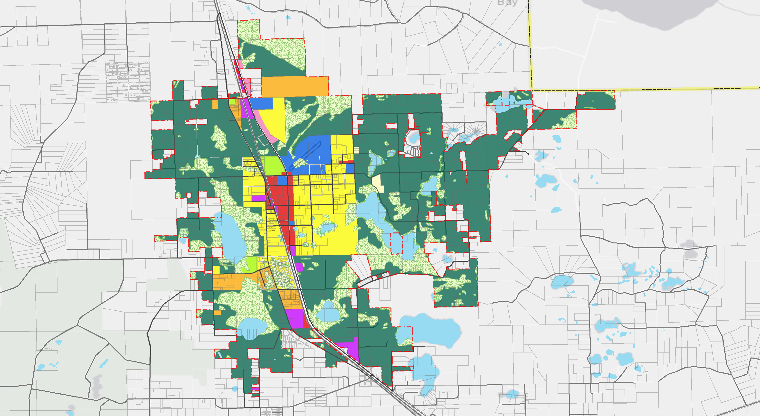´

DZITKO LN
H
BRADDOCK RD
TURNER RD

ORTH
LA
WESTERN AV
E HAGSTROM RD

TR

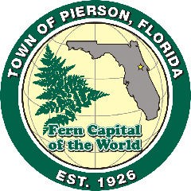
TOWN OF PIERSON
BLA
SAUL RD
BELL RD
FUTURE LAND USE ELEMENT

Town of Pierson Limits Volusia County Limits
Volusia County Parcels
Esri, HERE, Garmin, (c) OpenStreetMap contributors, and the GIS user community

LAND USE DESIGNATION ACRES
Agriculture & Rural Residential 3875.86
Conservation Lands 1247.97

PREPARED BY:

FUTURE LAND USE MAP
Streets
General Retail Commercial
General Retail Commercial (Low Intensity) Heavy Commercial & Industrial
Low Density Residential Medium Density Mobile Home Medium Density Residential Public/Institutional
112.99
30.4
69.11
17.23
287.49
691.40
166.32


5,000
2,500
0 5,000Feet
Recreation Lands 53.92
Water

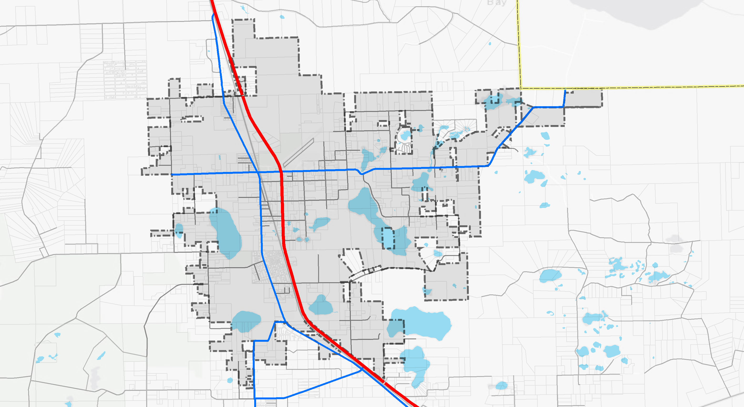´

DZITKO LN
BRADDOCK RD
TURNER RD

ORTH
LA
AV
HAGSTROM RD
E HAGSTROM RD

TR

TOWN OF PIERSON TRANSPORTATION ELEMENT
BLA
SAUL RD
BELL RD

FUTURE ROADWAY NETWORK MAP

Town of Pierson Limits Volusia County Limits
Volusia County Parcels
Esri, HERE, Garmin, (c) OpenStreetMap contributors, and the GIS user community

STREET TYPE
Principal Arterial Collector
Local

PREPARED BY:

5,000

2,500

0 5,000Feet

SOURCE: VOLUSIA COUNTY OPEN DATA SITE - STREET CENTERLINES IN VOLUSIA COUNTY, FL.

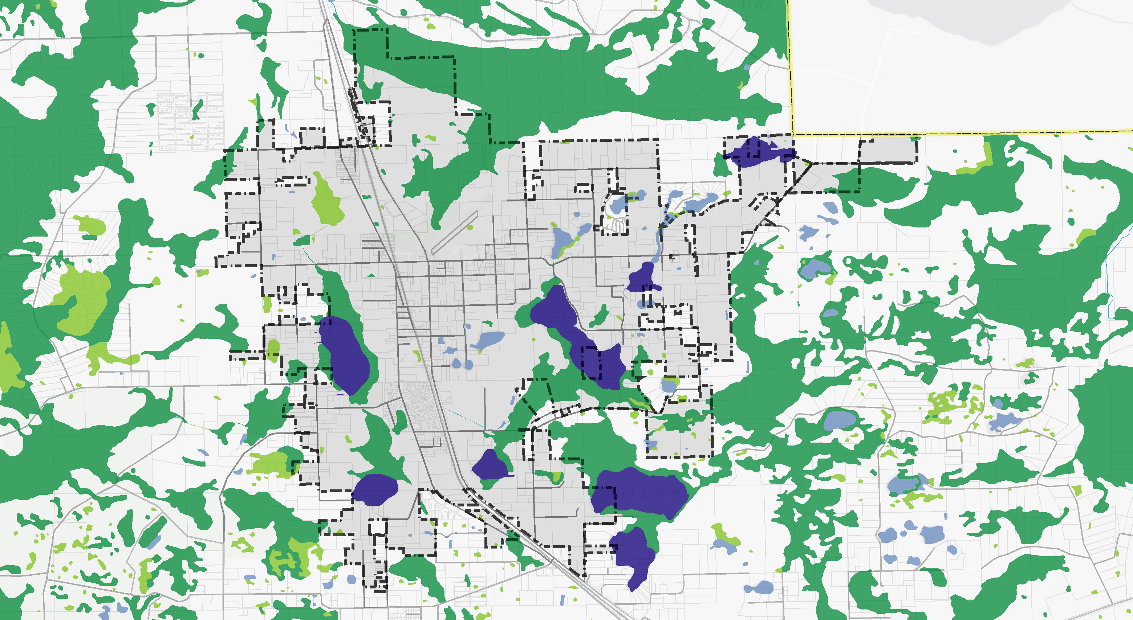´

DZITKO LN
H
BRADDOCK RD
TURNER RD

ORTH
LA
WESTERN AV
E HAGSTROM RD

TR

TOWN OF PIERSON
BLA
SAUL RD
BELL RD
COMPREHENSIVE PLAN CONSERVATION ELEMENT

Town of Pierson Limits Volusia County Limits
Volusia County Parcels
Esri, HERE, Garmin, (c) OpenStreetMap contributors, and the GIS user community

WETLAND TYPE ACRES
Freshwater Emergent Wetland 88.3
Freshwater Forested/Shrub Wetland 851.6

WETLANDS & SURFACE WATER BODIES MAP
Streets
Freshwater Pond
Lake Riverine
74.8
386.3
1.6

PREPARED BY:

5,000

2,500

0 5,000Feet

SOURCE: THE NATIONAL WETLANDS INVENTORY - SURFACE WATERS AND WETLANDS INVENTORY

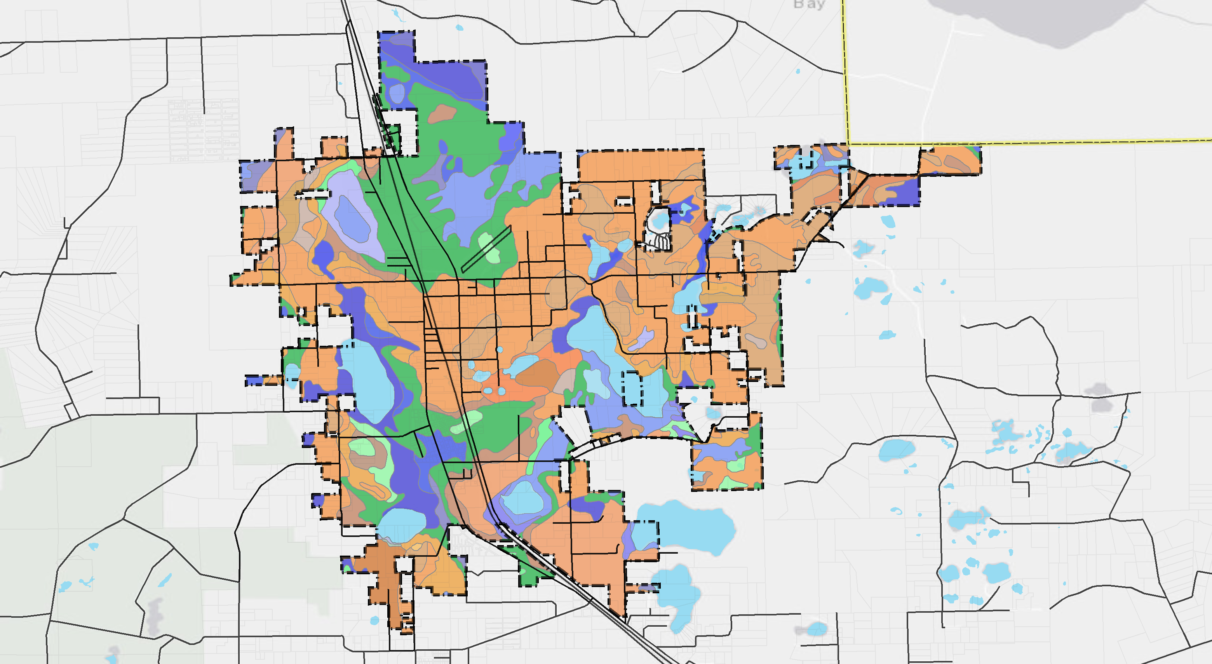34 66 ´

32
33

56 19
32 27 66
56
34 13
66
32 55
19 13
17 19 34 34 56
13

4 4
63 33
63
4 56 56

34
4 63
32
13

33 37 60
48
33 32 32
5
56 4
63
5 4 1 5 4
63 8 4
27

32
63
ROB

33 63
42 17
19 63
37
19 53
17
56 32
29
13 OHIO 17 ST

4

63 63
N CADE ST
53 13
4 57
53
8
5 32
4 0 63

53 63
17

29
32 17
34 17
34
E

32 17

17
4
SHAW
27
4 4 LAKE 48
22
42 56
4
HORN LAKE RD

37 5 27
LAKE
4 32

63
34 17 63
4

LAKE
27 PIERSON
34
1 32
37
22
13 63
17
32 27
56 61

63 4

32 37

4 29
32
56
32 17 13
E 5TH AV
17
63
19 29 63 56

27

63 57
17 29
WESTERN
AV
63
27 32
13
63
8

34
27

33
DRURY
LAKE 32
60

13 56

19
LAKE 32
BOTTS
61
32 13
37

63 56
32
HAGSTROM RD
27

CAIN LAKE
17 32
56
63
13 29 32

13
60 27
75 62
4
1
BELL RD

63 33
17 32

60 32
61
19 56 32

19 LAKE
5,000 2,500 0 5,000Feet
SAUL RD
63 32
56 INEZ
63

TOWN OF PIERSON

PETERSON RD
Town of Pierson Limits

SOIL TYPE
Esri, HERE, Garmin, (c) OpenStreetMap contributors, and the GIS user community

PREPARED BY:

COMPREHENSIVE PLAN CONSERVATION ELEMENT

SOILS MAP
Volusia County Limits Volusia County Parcels Water
Streets
1 Apopka Fine Sand; 0 to 5 Percent Slopes
- Astatula Fine Sand; 0 to 8 Percent Slopes
- Astatula Fine Sand; 8 to 17 Percent Slopes 8 Basinger Fine Sand; Depressional
13 Cassia Fine Sand
17 Daytona Sand; 0 to 5 Percent Slopes
19 Deland Fine Sand; 0 to 5 Percent Slopes
22 Electra Fine Sand; 0 to 5 Percent Slopes 27 Hontoon Mucky Peat
29 Immokalee Sand 32 Myakka Fine Sand
33 Myakka Fine Sand; Depressional 34 Myakka - St.Johns Complex
37 Orsino Fine Sand; 0 to 50 Percent Slopes
42 Paola Fine Sand; 0 to 50 Percent Slopes 48 Placid Fine Sand; Depressional
53 Pompano - Placid Complex 55 Riviera Fine Sand
- Samsula Muck
- Satellite Sand
60 Smyrna Fine Sand 61 St. Johns Fine Sand
62 St. Lucie Fine Sand; 0 to 8 Percent Slopes 63 Tavares Fine Sand; 0 to 5 Percent Slopes
66 Tomoka Muck
75 Wauchula Fine Sand

SOURCE: UNITED STATES DEPARTMENT OF AGRICULTURE NATURAL RESOURCE CONSERVATION SERVICE - FLORIDA GENERAL SOIL MAP.

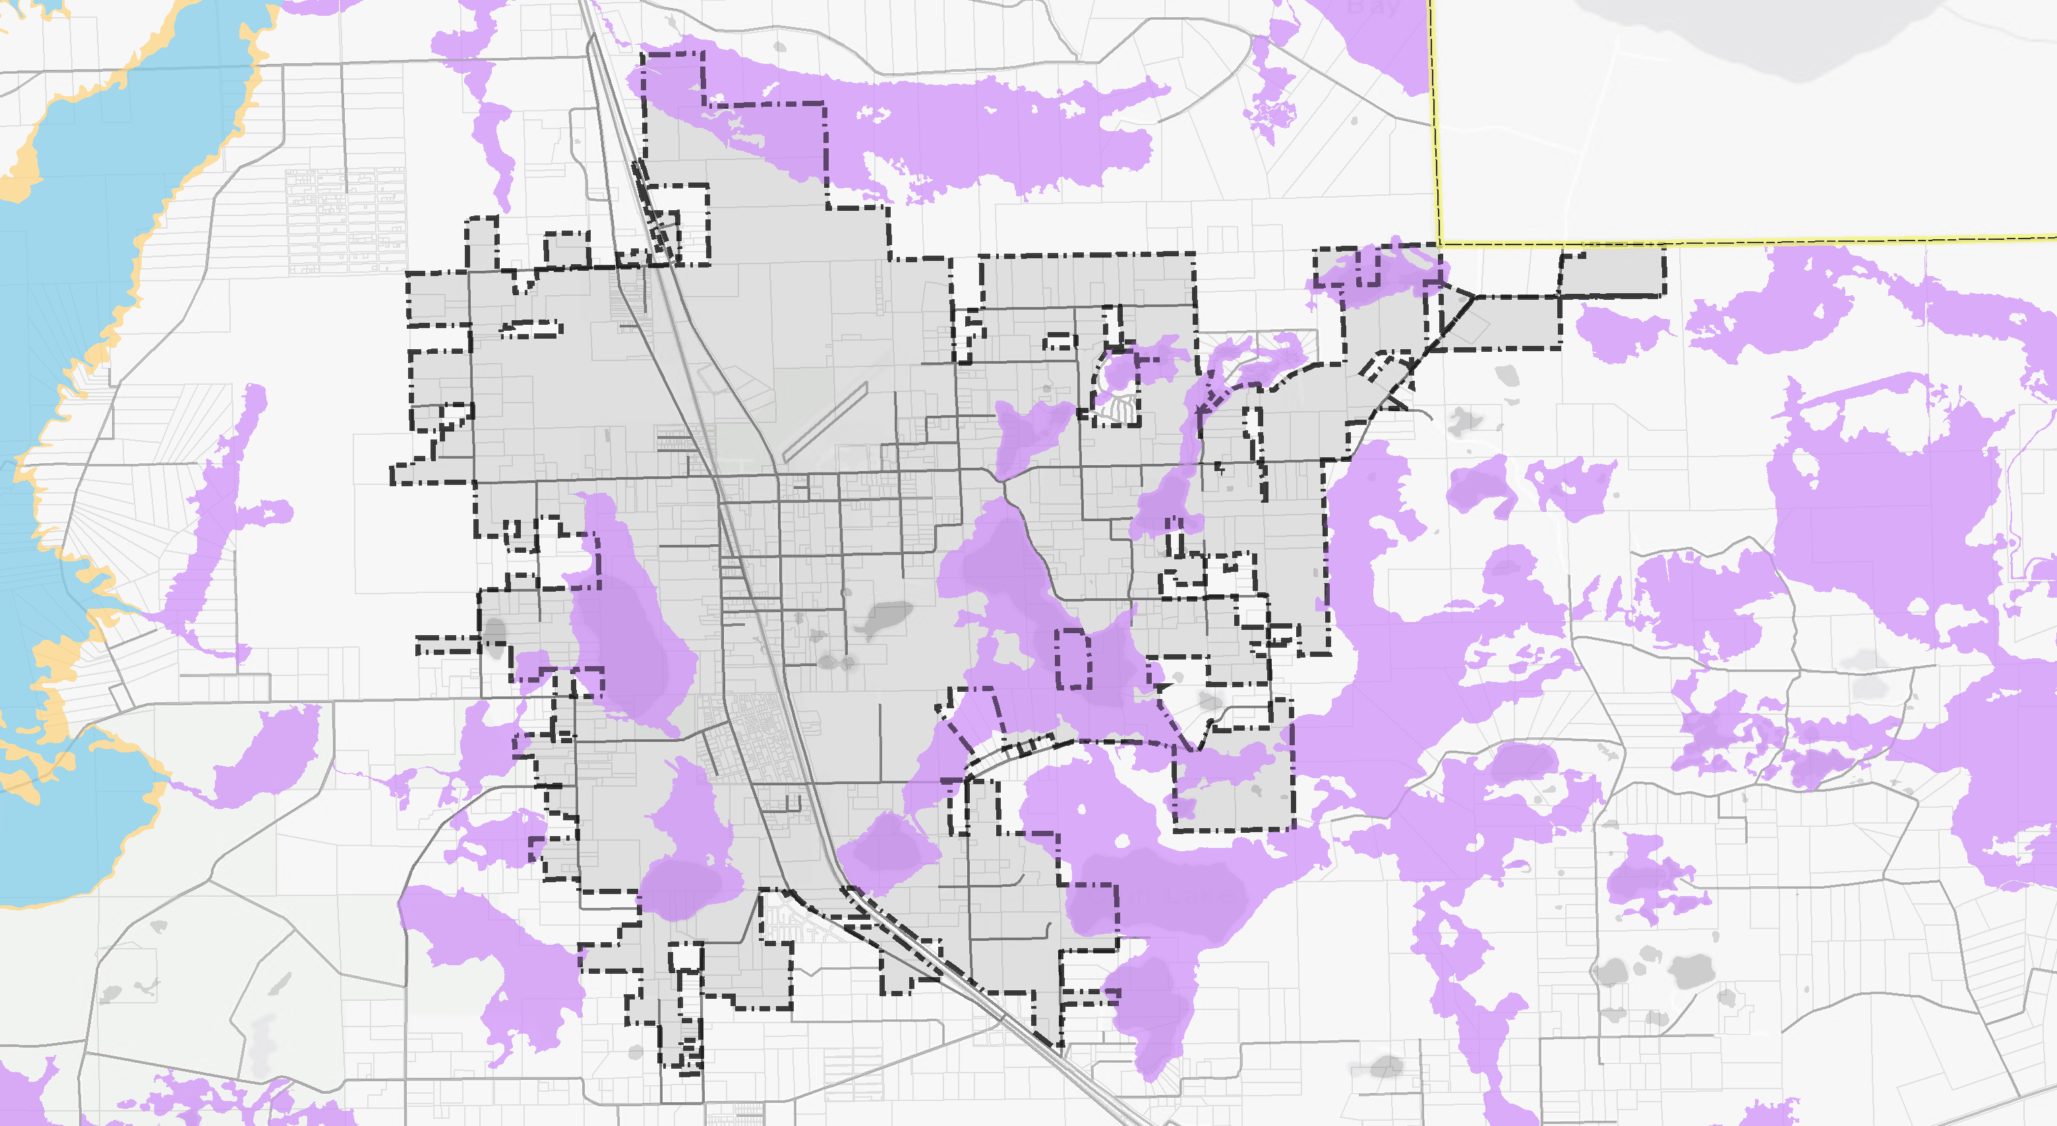´

DZITKO LN
H
BRADDOCK RD
TURNER RD

ORTH
LA
WESTERN AV
E HAGSTROM RD

TR

TOWN OF PIERSON COMPREHENSIVE PLAN CONSERVATION ELEMENT
BLA
SAUL RD
BELL RD

FEMA FLOOD INSURANCE RATE MAP

Town of Pierson Limits Volusia County Limits
Volusia County Parcels Streets
Esri, HERE, Garmin, (c) OpenStreetMap contributors, and the GIS user community

FLOOD RISK ZONES ACRES
0.2% Annual Chance Flood Hazard 0
A 1200.76
AE 0

PREPARED BY:

5,000

2,500

0 5,000Feet

SOURCE: VOLUSIA COUNTY OPEN DATA SITE - FEMA FLOOD INSURANCE RATE MAP FOR VOLUSIA COUNTY, FL.

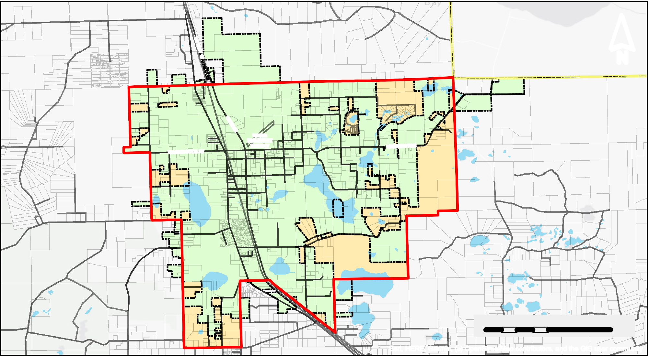
´

WATER TREATMENT FACILITY

SHAW LAKE

LAKE PIERSON

DRURY LAKE

LAKE BOTTS

CAIN LAKE

LAKE INEZ

5,000

2,500

0 5,000Feet

TOWN OF PIERSON COMPREHENSIVE PLAN UTILITIES ELEMENT

WATER SERVICE AREA MAP

LEGEND

Pierson Water Service Area Volusia County Limits
Town of Pierson Limits Unincorporated Volusia County Volusia County Parcels Waterbodies
Streets
Esri, HERE, Garmin, (c) OpenStreetMap contributors, and the GIS user community

PREPARED BY:

TOWN OF PIERSON COMPREHENSIVE PLAN 2040

TRANSPORTATION
ELEMENT GOALS, OBJECTIVES AND POLICIES

TE Goal I - Provide a safe, convenient, efficient and coordinated multi-modal transportation system that sustains the town’s small town character and maintains it’s rural, and aesthetic characteristics while minimizing and reducing greenhouse gas emissions and other environmental impacts.

TE Objective I-1.1 - The Town shall coordinate with Volusia County, the Florida Department of Transportation and the Volusia Transportation Planning Organization (VTPO) to achieve and maintain levels-of service on the town’s road system that is illustrated in the Future Transportation Map.

TE Policy I-1.1.1 - The Town establishes the following functional designations and adopted level of service (LOS) for these major roadways within the town boundaries. All other roadways within the town boundaries are considered local roads:

Roadway | Designation | Adopted LOS
US 17 | Rural Arterial | C
CR3 | Rural Collector | C
Blackburn Road | Rural Collector | C
Washington Avenue | Rural Collector | C

TE Policy I-1.1.2 - The Town shall review all proposed developments for compliance with this Plan. No development shall be approved until a determination has been made that said development complies with the requirements of this Plan and the Land Development Regulations.

TE Objective I -1.2 - The needs of pedestrians and bicyclists shall be accommodated in all road construction and reconstruction projects whenever possible and appropriate.

TE Policy I-1.2.1 - The Town shall continue to enforce the Land Development Code’s design standards to insure that the needs of pedestrians and bicyclists are met.

TE Policy I-1.2.2 - The Town shall prohibit parking on the paved portion of all arterial and collector roads.

TE Policy I-1.2.3 -As a minimum, developers shall be required to install sidewalks along one side of all new streets.

TE Policy I-1.2.4 - The Town shall continue to expand its bike/sidewalk system whenever it can be accomplished in a fiscally sound manner.

TE Policy I-1.2.5 - The Town shall strive to have pedestrian roadway crossings comply with the Florida Pedestrian Planning and Design Handbook (Current Edition).

TE Objective I-1.3 - The Town’s road network shall emphasize safety and aesthetics.

TE Policy I-1.3.1 - The Town shall continue to enforce its Land Development Code regulations that require minimum design standards for landscaping and signage along all roads. The regulations shall require that, where possible, natural landscaped buffers shall be maintained along arterial and collector roads.

TE Policy I-1.3.2 - The Town shall continue to utilize its written administrative procedure to monitor citizen complaints regarding road conditions and accident data in order to identify and correct deficient road conditions.

TE Policy I-1.3.3 - Safety shall be a major concern in all matters of road design and construction and traffic management. Therefore, the Town shall continue to ensure that all new roads and road improvements are consistent with the policies of this Element and will conform to the Florida Department of Transportation’s Manual of Uniform Minimum Standards for Design, Construction and Maintenance for Streets and Highways and the Federal Highway Administration’s Manual on Uniform Traffic Control Devices on Streets and Highways.

TE Policy I-1.3.4 - The Town shall continue to enforce the Land Development regulations on road access management provisions to minimize the loss of traffic capacity on arterial and collector roads due to turning movements. These provisions shall include: 1) minimum spacing of curb cuts, 2) off-street vehicle circulation areas providing sufficient turn-around space to allow vehicles to enter the roadway in a forward direction, and 3) adequate on-site vehicle storage space to allow turning vehicles to fully clear the roadway while pausing for on-site traffic.

TE Policy I-1.3.5 - The Town shall continue to enforce its land development regulations requiring all land uses to have safe and convenient on-site circulation, adequate off-street parking and loading/unloading areas for both motorized and non-motorized vehicles, as applicable.

TE Objective I -1.4 - Preserve existing and future investment in the road system.

TE Policy I-1.4.1 - The Town shall continue to utilize its established administrative procedures for monitoring and evaluating the condition of all roads for which it has maintenance responsibility. This evaluation shall serve as the basis for prioritizing road maintenance and resurfacing projects.

TE Policy I-1.4.2 - The Town shall continue to monitor its minimum standards and requirements for road construction, and revise such standards and regulations if necessary to ensure, long, trouble free service with a minimum of maintenance effort.

TE Policy I-1.4.3 - The Town shall continue to enforce residential subdivision design standards which discourage direct driveway access to arterial and collector roads.

TE Policy I-1.4.4 - The Town shall continue to require that building setbacks along substandard width rights-of-way be measured from the hypothetical right-of-way line for a standard width right-of-way.

TE Objective I-1.5 - The Town shall ensure that it’s Goals, Objectives and Policies are communicated to the VTPO and reflected in the VTPO’s plans and programs for all classified roadways on the Future Transportation Map.

TE Policy I-1.5.1 - All road improvements included in the Town’s Traffic Circulation Element shall be compatible with the plans and programs of the Volusia Transportation Planning Organization (VTPO).

TE Policy I-1.5.2 - The Town shall ensure that the plans and programs of the VTPO are based on the future land use projections of the Town’s Future Land Use Element.

TOWN OF PIERSON COMPREHENSIVE PLAN 2040

HOUSING ELEMENT GOALS, OBJECTIVES AND POLICIES

HOU Goal I: Planning for Housing Needs of Present and Future Residents. Provide sufficient safe and sanitary housing to meet the needs of present and future residents.

HOU Objective I-1.1: Meet Housing Needs of Present and Future Residents. The Town will assist in planning for the provision of sufficient safe and sanitary housing for all current and anticipated future residents by ensuring the provision of adequate infrastructure and appropriate residential land use categories to accommodate projected growth in population and a range of housing types, including adequate sites and distribution of housing for very low, low, and moderate income households.

HOU Policy I-1.1: Actions to Encourage Provision of Housing in Area with Supportive Infrastructure. Coordinate with local, federal and state public initiatives and the private sector to assist in developing needed facility improvements within areas having existing infrastructure in order to minimize the need for additional local services and avoid the concentration of affordable housing units only in specific areas of the jurisdiction.

HOU Policy I-1.2: Ensure Adequate Land for Accommodating Needed Housing. In the future land use element, the Town will provide adequate land area to meet the housing needs as required by the selected average density.

HOU Objective I-2: Eliminate Substandard and Dilapidated Dwelling Conditions. The Town shall promote the elimination of substandard and dilapidated dwelling conditions and achievement of relocation housing for displaced persons by implementing the following policy.

HOU Policy I-2.1: Promote Code Enforcement and Eliminate Substandard Housing. Enforce building, housing and property maintenance codes to prevent and upgrade substandard housing while joining local, federal and state efforts to build public/private partnerships to implement rehabilitation of substandard housing and redevelopment of areas with deteriorating or dilapidated housing while assisting in achieving relocation housing for persons displaced by redevelopment.

HOU Policy I-2.2: Enforce Building Codes. Continue to adopt and enforce the latest edition of the uniform building codes.

HOU Policy I-2.3: Enforce Housing Code. Continue to enforce the adopted housing code.

HOU Policy I-2.4: Implementing Code Enforcement. Provide trained inspection staff on an in-house or contract basis to enforce the adopted building and housing codes.

HOU Policy I-2.5: Rehabilitation Assistance. Expand efforts to utilize state and federal housing rehabilitation assistance pending the availability of funding.

HOU Policy I-2.6: Code Enforcement and Housing Requiring Upgrades or Demolition. Vacant dilapidated housing units shall be identified through the Town's continuing code enforcement program and rehabilitated or demolished.

HOU Policy I-2.7: Relocation Housing. Relocation housing needs created by Town property acquisition shall be provided as required by law.

HOU Objective I-3: Achieving Balanced Housing Supply Responsive to Consumer Demand and Special Needs. Plan for a balanced future housing supply responsive to consumer demand and ensure that such future residential development is constructed on sites having adequate supporting infrastructure and public facilities by implementing the following policy:

HOU Policy I-3.1: Achieve Balanced Inclusive Housing Supply Responsive to Consumer Demand and Affordable Housing. Enforce the Town’s Comprehensive Plan Future Land Use Map and zoning to ensure the well planned location and timing of housing investments and provision of adequate public facilities while joining local, federal and state efforts to build public/private partnerships that promote residential development responsive to consumer demand and avoids the concentration of affordable housing units only in specific areas of the jurisdiction.

HOU Policy I-3.2: Potable Water Service. Provide potable water to serve existing and new residential areas.

HOU Policy I-3.3: Subdivision Lot Size and Compliance with Mandated Central Water System Regulations. The Town shall require each new subdivisions to install a central water system at the developer's expense as required in the land development code.

HOU Policy I-3.4: Regulation of Lot Sizes; Septic Tank and Soil Suitability. Establish minimum lot sizes appropriate to the use of septic tank systems in areas with sites having soils suitable for accommodating septic tanks and drain fields.

HOU Policy I-3.5: Remove Regulatory Barrier to New Development. Review all local development codes to identify and remove any unnecessary regulation which may

serve as a barrier to new development or unnecessarily increase the cost of new residential development.

HOU Objective I-4: Meeting Affordable Housing Needs of Low- and Moderate Income Households with Severe Housing Cost Burdens. The Town will assist in planning for housing assistance needs by exchange of information, referral, promoting awareness of public and private resources available to very low-, low- and moderate-income households eligible for federal assistance having severe housing burdens [i.e., household incomes < 80% HUD Area Median Income (AMI).

HOU Policy I-4.1: Coordinating the Future Land Use Map Policies with Housing Needs. In the future the land use element shall provide adequate land area and density to meet the housing needs.

HOU Policy I-4-2: Town Participation in Volusia County Process for Allocating Section 8 Housing. The Town shall continue to participate in the use of Existing Section 8 housing units through the Volusia County allocation.

HOU Policy I-4-3: Continued Information and Referral System for Housing Assistance. The Town shall continue to provide information referral and assistance that links Town of Pierson residents in need of housing assistance with the Volusia County resources for housing and related special needs assistance and other state and local housing assistance programs.

HOU Objective IV-5: Neighborhood Stabilization and Improvements Residential Quality. The Town shall continue to maintain stabilized neighborhoods and residential quality by implementing the following policy.

HOU Policy I-5.1: Actions to Achieve Neighborhood Stabilization and Improvements Residential Quality. Pursue neighborhood stabilization grants that target housing and facility improvements needed by the Town and do not overburden the Town’s manpower or financial resources and, in addition, monitor new permitting and code enforcement techniques and consider adopting such techniques with demonstrated potential to minimize costs and delays for affordable housing.

HOU Objective I-6: Accommodating Mobile Homes. Provide sites for mobile homes that relate to the expected demand for mobile home units and consistent with accepted criteria for land use compatibility and property maintenance.

HOU Policy I-6.1: Mobile Homes and Farmworker Housing. Provide zoning regulations to allow mobile homes as farmworker housing in support of bona fide agricultural uses.

HOU Policy I-6.2: Land Needs for Mobile Homes. Review zoning regulation to ensure that adequate land area as identified in the Future Land Use Element is available to accommodate mobile homes in line with the expected demand.

HOU Policy I-6.3: Ensure Regulatory Measures Responsive to Mobile Home Standard Specifications and Spatial Needs. Review zoning regulations to ensure that minimum floor area requirements in residential zoning districts that allow mobile home use that accommodate standard mobile home units.

HOU Objective I-7: Group Homes and Supportive Regulatory Measures. Provide regulations to support sites for group homes, foster care facilities and related special housing needs.

HOU Policy I-7.1: Group Home Regulations and Compliance with Federal and State Law. Review the Town’s Uniform Land Development Code to ensure compliance with state statutes and case law pertaining to local government regulatory practices impacting group homes.

HOU Policy I-7.2: Group Homes and Foster Care Facilities to Be Regulated Consistent with State Standards. Continue to allow group homes and foster care facilities as special uses in all residential districts consistent with current state standards.

HOU Policy I-7.3: ACLF and Similar Facilities. Allow by special use permit in any residential zone Adult Congregate Life-care Facilities (ACLF) units and similar group homes provided that a minimum spacing of 1000 feet is maintained between any such facilities.

HOU Objective I-8: Historically Significant Housing. The Town shall promote availability of public information identifying historically significant housing and encourage actions to protect and conserve historically significant housing by implementing the following policy.

HOU Policy I-8.1: Protection and Conservation of Historically Significant Housing. The Town shall coordinate with the Florida Division of Historic Resources and seek assistance to monitor and update the Town’s inventory of historic housing while joining local, federal and state efforts to build public/private partnerships to implement programs to identify, conserve and protect historic sites and buildings.

TOWN OF PIERSON COMPREHENSIVE PLAN 2040

Utilities Element Goals, Objectives and Policies

SANITARY SEWER, SOLID WASTE, DRAINAGE,
POTABLE WATER, AND NATURAL GROUNDWATER AQUIFER RECHARGE ELEMENT

SS Goal I: To provide for the disposal of all wastewater generated in the Town in the most economical, environmentally sound, and cost efficient manner possible.
SS Objective I-1: The Town shall enforce its Land Development Regulations requirements for development review, and update as necessary, to ensure that, at the time a development permit is issued, an adequate wastewater treatment system is provided to serve the development.
SS Policy I-1.1: The following level of service standard is hereby adopted, and shall be used as the basis for determining the availability of facility capacity and the demand generated by a development:
Pending availability of a central wastewater collection, transmission and treatment facility, 90 gallons per day per capita for septic tanks & 175 GPD/ERU for residential,
0.15 GPD per sq. ft. of building for Office, 0.10 GPD per sq. ft of building for Retail, Institutional and Industrial connections.
SS Policy I-1.2: Pending availability of a central wastewater collection, transmission and treatment facility, issuance of development orders or permits will be conditioned upon demonstration of compliance with applicable federal, state and local permit requirements for septic tanks.
SS Policy I-1.3: The Town of Pierson considers the construction of wastewater collection, transmission and treatment facility system to be of utmost importance to the health, safety and welfare of the community.
SS Policy I–1.4: Package wastewater treatment plants may be considered for use as interim and temporary facilities. However, when wastewater services do become available, package plants shall be discontinued, and the development served by such package plants shall be connected to the central facilities.
SS Objective I-2: The Town will continue to cooperate with the Volusia County Health Department and the Volusia County Environmental Management Department to promote periodic inspection and maintenance of septic tanks.
SS Policy I-2.1: The Town shall encourage periodic inspection and maintenance of septic tanks through education and incentive programs.

SW Goal I: Provide for the collection and disposal of household, commercial, and construction solid and hazardous wastes in a manner that is convenient, environmentally sound, sanitary, and cost efficient.
SW Objective I-1: In cooperation with the County’s Solid Waste Management Division and the Town’s private waste hauler, the Town shall review its current methods for disposal of solid and hazardous wastes and its recycling efforts to ensure that these wastes are being disposed/recycled in the most environmentally sensitive and cost-efficient means.
SW Policy I-1.1: The Town shall monitor activities within the town that are known to use hazardous materials in order to ensure compliance with applicable handling and disposal rules and guidelines
SW Policy I-1.2: The Town shall encourage citizens to utilize the County’s facilities at its landfill to dispose of household hazardous wastes and, in cooperation with the County’s Solid Waste Management Division, establish periodic local collection opportunities.
SW Policy I-1.3: - The Town shall cooperate with the Volusia County Department of Environmental Protection Agency to promote better awareness of the need for proper disposal of hazardous wastes.
SW Objective I-2: Encourage citizens to deposit recyclable wastes at the current collection point and explore curbside collection as a part of the review addressed in Objective 2.1, above.
SW Policy I-2.1: Pierson will coordinate and cooperate with Volusia County and the Town’s current waste collection franchise to explore the feasibility of curbside collection of recyclable wastes.
SW Policy I-2.2: Per the Data, Inventory and Analysis, the Town hereby adopts a level of service standard of 1.8 pounds per capita per day for solid waste collection and shall ensure that the private franchised solid waste collector has the capacity to provide that level of service for the population of Pierson.
STW Goal I: Provide adequate stormwater management to protect human life and health and the value of property, and to prevent degradation of water quality in the lakes and the aquifer.
STW Objective I.1: The Town shall enforce Article VII of its land development regulations which establishes criteria and procedures for determining whether proposed stormwater management systems are adequate to prevent flooding and degradation of natural surface waters.
STW Policy I-1.1: In order to determine the adequacy of a proposed stormwater management system, the following level of service standard is hereby adopted:
- The discharge hydrograph produced for the developed or redeveloped site shall not exceed in terms of peak flow and total volume, the hydrograph produced by conditions existing before development or redevelopment for a twenty-five-year

frequency, twenty-four hour duration storm. However, the first one inch of rainfall for each storm falling on all areas caused by or resulting from the project shall be retained on site. In addition, the cumulative impact of the outflow hydrograph on downstream flow shall be considered. Runoff rates and volumes resulting from the project, in excess of existing amounts, shall be accommodated on-site.
- The peak discharge resulting from a one-hundred-year frequency storm on the developed or redeveloped site shall not exceed the peak discharge resulting from a one hundred year frequency storm for existing conditions on the site.
PO Goal I: Provide adequate quantity and quality of potable water to meet the demands of the present and future population for consumption and other purposes.
PO Objective I-1: No use or development of land shall occur in Pierson unless adequate water system capacity is available or will be available when needed to serve the development.
PO Policy I-1.1: A level of service standard of 56 gallons per capita per day (total demand for all users/current population) is hereby adopted, and shall serve as the basis for determining the availability of adequate water system capacity
PO Policy I-1.2: The Town shall not issue development orders or development permits without first determining whether adequate water supplies to serve the development will be available no later than the anticipated date of issuance by the Town of a certificate of occupancy per the Town’s potable water concurrency system of its Land Development Regulations.
PO Policy I-1.3: The Town, in accordance with the Volusia County Comprehensive Plan, shall enter into an interlocal agreement with the county for those portions of its potable water service area outside the Town’s corporate limits.
PO Objective I-2: The Town shall maintain a five-year schedule of capital improvement needs for public facilities, to be updated annually in conformance with the review process for the Capital Improvements Element of this Plan.
PO Policy I-2.1: Potable water facility projects shall be undertaken in accordance with the Capital Improvements Element of this Plan.
PO Policy I-2.2: All improvements for replacement, expansion or increase in capacity of the potable water system shall be compatible with the adopted level of service standards for the facility.
PO Policy I-2.3: To the greatest extent possible, the cost of providing potable water system improvements will be borne by those benefiting from such improvements.
PO Policy I-2.4: New developments shall be required to pay the full cost of potable water system improvements needed to serve only those developments, and the proportionate cost of improvements needed to serve more than one development.

PO Policy I-2.5: The Town of Pierson’s 10 Year Water Supply Facilities Work Plan, shall be updated, at a minimum, every 5 years within 18 months after the St. John’s River Water Management District approves its updated regional water supply plan. The work plan located within this Potable Water Sub-Element identifies existing and projected water use and existing and alternative potable water sources, evaluates/updates the Town’s conservation and reuse efforts and identifies capital improvement projects necessary to meet the needs of existing and projected development.
PO Objective I-3: The Town recognizes the importance of water conservation and will continue to implement water conservation practices. The Town will also explore options to develop Alternative Water Supplies, AWS, to reduce potable water demand.
PO Policy I-3.1: The Town shall continue to enforce building code requirements for water saving fixtures in new construction and substantial rehabilitation.
PO Policy I-3.2: The Town shall ensure the removal of plants that require high water consumption when redeveloping Town properties and replace with water-wise landscape materials. All new developments within the Town shall utilize waterwise landscape materials.
PO Policy I-3.3: The Town shall amend the Land Development Code to promote and encourage the use of low impact development techniques.
PO Policy I-3.4: The Town shall require the establishment of a water conservation plan for new subdivisions and planned unit developments. Each plan shall include at a minimum the following: installation of low flow fixtures, indoors and outdoors; and use of waterwise landscape materials.
PO Policy I-3.5: The Town will investigate grant opportunities for financing stormwater for irrigation and other nonpotable uses in the community.
PO Policy I-3.6 - The Town will continue to implement SJRWMD’s lawn and landscape irrigation rule.
PO Policy I-3.7 - The Town will enforce watering restrictions consistent with the District’s lawn and landscape irrigation rule.
PO Policy I-3.8 - The Town shall continue to implement the following water distribution system conservation measures:
  - Continue Implementation of an inclined block rate structure.
  - Perform meter calibrations, water audits and a leak detection programs to reduce the potential for any wasteful system losses.
  - Continue the customer education program and expand where financially feasible.
  - Continue to ensure that all service connections are metered.
  - Maintain all water meters.

  - Continue to disallow master water meters.
  - Continue to implement the water conservation plan received by SJRWMD on September 7, 2007.
  - Provide incentives for water conservation in new developments.
  - Implement public education and outreach programs.
PO Policy I-3.9 - The Town shall explore and study methods to reduce average potable water demand with particular emphasis placed on reducing landscape irrigation.
PO Policy I-3.10 - The Town will explore all financially feasible Alternative Water Supply, AWS, efforts that can be implemented by the Town.
PO Policy I-3.11 - The Town shall utilize lower quality sources of water for nonpotable needs when such sources (storm water, surface water, reclaimed water) are available and financially feasible.

POTABLE WATER SUB-ELEMENT – PIERSON WATER SUPPLY PLAN

Federal

The federal government has established quality standards for the protection of water for public use, including operating standards and quality controls for public water systems. These regulations are provided in the Safe Drinking Water Act (PL 93-523). This law directed the Environmental Protection Agency (EPA) to establish minimum drinking water standards. The EPA standards are divided into "primary" (those required for public health) and "secondary" (recommended for aesthetic quality) categories.

State
In accordance with federal requirements, the Florida Legislature has adopted the Florida Safe Drinking Water Act, Sections 403.850-403.864, F.S. The FDEP is the state agency responsible for implementing this act. In this regard, FDEP has promulgated rules classifying and regulating public water systems under Chapter 17-22 of the FAC. The primary and secondary standards of the Federal Safe Drinking Water Act are mandatory in Florida.

The St. Johns River Water Management District (SJRWMD) is responsible for managing water supplies to meet existing and future demands. Allocation of limited water resources is achieved through a permitting process applicable to large volume users. The SJRWMD rules pertinent to Pierson are contained in Chapter 40C-2, FAC.

In 2005, the Florida Legislature passed Senate Bills 360 and 444 which are intended to improve the coordination of water supply planning and land use planning through the strengthening of the statutory linkage between the regional water supply plans prepared by the respective water management districts and the comprehensive plans prepared by the local governments.

As a result of this legislation, all local governments subject to a regional water supply plan must revise their comprehensive plans within eighteen months after the approval of the regional water supply plan. Pierson lies within the St. John’s River Water Management District (SJRWMD). The 2020-2040 District Water Supply Plan was approved by the SJRWMD Governing Board on February 8, 20221. The Town prepared its first Water Supply Facilities Work Plan (WSFWP) in 2010 in conformance with Section 163.3184(3)(a) FS and Rule 9J-11.006(1)(a)3 FAC.2 The plan amendment

1 Central Springs/East Coast Regional Water Supply Plan; 2020 - 2040 February 7th, 2022 (sjrwmd.com)
2 Exhibit V-A, Town of Pierson Water Supply Facilities Work Plan, FY 2010-2020

was reviewed by the WMD, found in compliance by FDCA and received a Consistency Certification from the VGMC. As stated in the amendment, the WSFWP has been incorporated in this Sub-Element’s Data, Inventory and Analysis and Goals, Objectives, and Policies. Following adoption of the SJRWMD 2020-2040 District Water Supply Plan, the Town updated the sub-element’s data in the WSFWP using a 2020-2040 planning period.

Local
The Town has enacted regulations requiring connection to the Town's potable water distribution system when reasonably available.

UTILITY SERVICE AREA
- Service Area Description

- Description of Service Area
The Town of Pierson is a small, rural community located in northwest Volusia County. Geographically, it is situated separate and apart from other communities. US Highway 17 links the Town to the unincorporated communities of Barberville and Seville, located about 5 miles to the south and 4 miles to the north, respectively. Deland, the County Seat, is located about 16 miles to the south. The Town is approximately 6,694 acres or 10 square miles in area. As shown on Figure 1, the service area for the Town of Pierson’s central water system is generally the Town’s corporate limits with some unincorporated land included and some incorporated land excluded. The Town is the sole provider of potable water to its service area. The Town does not have any agreements with other potable water suppliers to provide water to the Town. Per the County’s Comprehensive Plan, when municipalities include unincorporated land within their potable water service area, an interlocal agreement with the County is required.
- Current Flow/Population Served/Per Capita Usage
According to the SJRWMD 2020-2040 District Water Supply Plan, Appendix B, Table 5, the population served and water use for 2015 was 2,657.Using this data, the total average daily water use for all users (residential, commercial, industrial and water system) in 2015 was 159,000 gallons. Using SJRWMD population of 2,657 per capita consumptions would equate to approximately 59.84 gallons per day3. The data supporting the Town’s most recent Consumptive Use Permit, CUP, application, submitted October 15, 2010, and approved on November 24, 2010, predicted the Town’s 2020 population at 2,877 and an average daily withdrawal of 140,000 gallons and a per capita consumption of 48.66 gallons per day. The 2020 US Census accounted for a total population of 1,542. However, whether the per capita consumption is ~60 gallons per day or ~49 gallons per

3 Appendix B - Population and Water Demand Projections (sjrwmd.com)

day, the per capita consumption rate for all users is very low. For Level of Service, LOS, purposes, Policy 4.1.1 was amended to reduce the level of service to 56 gallons per day per capita.

Figure 1
Town of Pierson Potable Water Service Area (Formerly Figure 1)
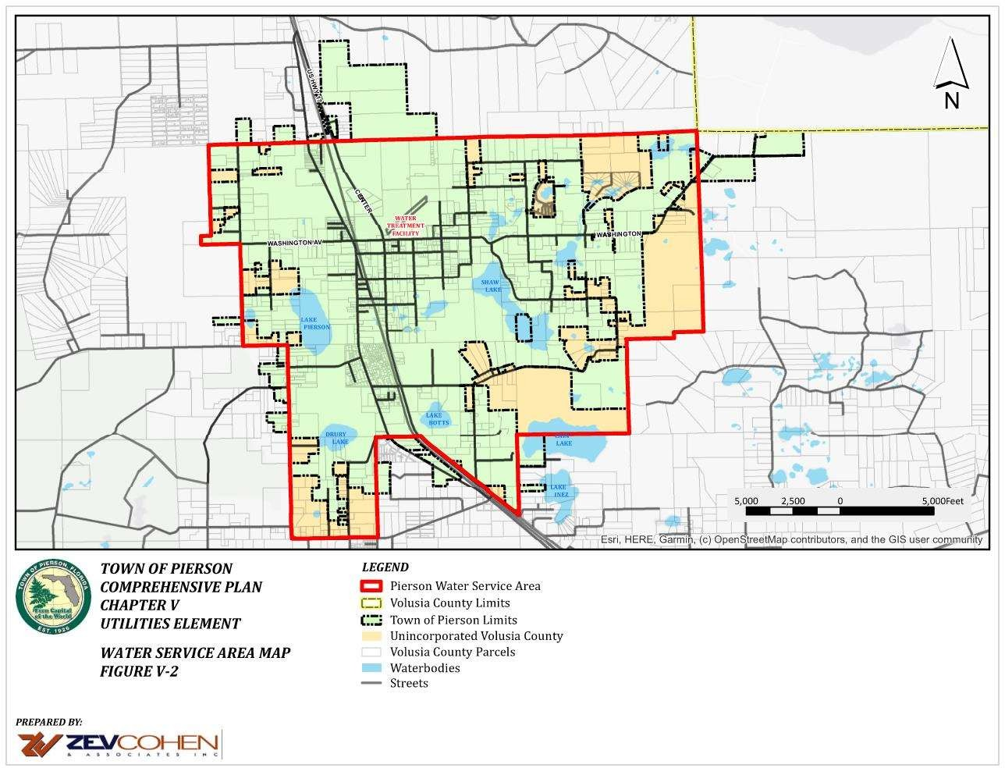

EXISTING AND ALTERNATIVE WATER SOURCES, LAWS
The Town of Pierson originally installed its domestic potable water system in 1990, at which time the Town had a population of 1,147. The potable water system served 500 of the Town’s then 544 households. The main reason the Town decided to construct the system was to eliminate the community’s reliance on private potable water supply wells. These relatively shallow wells were adversely affected by lowered groundwater tables during freeze periods when local ferneries would pump large volumes of water for freeze protection from the surficial aquifer. Initial funding for the construction of the system was

provided by a grant from the Farmers Home Administration and revenue bonds issued by the Town.

The existing water production system consists of two (2)-10" wells located on the corner of the T.D. Taylor Middle-High School property. The Town has an easement for the wells from the Volusia County School Board. Both wells draw from the Floridan Aquifer some 200 feet below the ground surface. Submersible turbine pumps produce 200 gallons of water per minute (gpm) from each well. With 24-hour pumping, daily production capacity is 288,000 for each well (576,000 for both). However, under normal operating conditions the pumps will not be running continuously. The realistic capacity might be figured with the two pumps alternating with a combined running time of 24 hours per day. This is a more acceptable procedure from a hydrological perspective since it allows the water level in each well time to recover between pumping. A generator located at the well site provides emergency power for the pumps.

The Town in its prior Consumptive Use Permit was authorized to construct an additional 12-inch diameter well on a parcel located north of Echo Street and east of the CSX Railroad right-of-way. The Town drilled a test well at the approved site and determined that there were water quality problems at that site. A second test well was drilled north of Washington Street and no significant water quality problems were identified. The Town recognizes that if a new well is to be drilled at this alternative location, the current CUP will have to be modified. The timing of drilling the new well and making it operational is subject to the availability of funds. The Town, utilizing a consultant has prepared a Water Facility Upgrade report that once finalized will be submitted to the U.S. Department of Agriculture in support of a grant application to fund water system improvements. The report provides three alternative solutions for water distribution system improvements necessary for providing adequate fire flows to the proposed regional public school as shown on Figure V-2. All three alternatives include construction of the new well.

The quality of raw water from existing wells is good, requiring only chlorination, which is provided by a chlorination unit located at the well site. Water storage facilities consist of a small (2,500 gallon) hydro-pneumatic tank located at the well site and a 250,000-gallon elevated storage tank located west of the intersection of 3rd Avenue and US Hwy 17. Refer to Figure 1 for well and elevated storage tower locations. The 250,000-gallon elevated water storage tank was installed to provide storage for system capacity, to maintain a constant pressure on the town water system, and to provide domestic water during extended periods of power loss.

The 4th Addendum to the St. Johns River Water Management District’s Water Supply Plan 2005 identified the Coquina Coast Desalinization Plant as an AWS option for the Town. Due to financial limitations, it is not practical for the Town to participate in a large regional

project such as Coquina Coast. The Town will explore other options for developing AWS, such as utilizing stormwater as an AWS. To meet the requirements of Section 163.3177(6)(c), F.S., the Town provided this same response to the District prior to this water supply planning comprehensive plan amendment being transmitted for review. Even though the Town’s current CUP is adequate to meet projected demand for potable water, the Town recognizes that the aquifer is a limited resource and all communities, big or small, must do their part to conserve this valuable resource.

WATER AND RECLAIMED WATER SYSTEMS
The Town does not have a central wastewater collection and treatment system and is not expected to have a system within the time frame of this current Plan. Also, there is not in proximity a wastewater system operated by others that could provide reclaimed water to the Town. The Town is committed to using lower quality sources of water for nonpotable needs when such sources are available and financially feasible, see new Policy 4.3.11. The District has required fern growing operations to install retention ponds as an alternative source of irrigation water as a condition to issuance of their irrigation CUP’s.

WATER USE, CUP STATUS, CAPITAL NEEDS & WATER SOURCE PROTECTION
- Historic Water Use & Demand Projections

According to the Town’s prior Comprehensive Plan, in 1990, the average daily water demand was about 113,000 gallons, with the middle-high school and the elementary school combined accounting for 33,000 gallons. Based on the Town’s 1990 population of 1,147, total demand would equate to an average per capita daily demand for all users of
98.5 gallons.
As stated above, the data supporting the Town’s most recent Consumptive Use Permit, CUP, application, submitted October 15, 2010, and approved on November 24, 2010, predicted the Town’s 2020 population at 2,877 and an average daily withdrawal of 140,000 gallons, and a per capita consumption of 48.66 gallons per day. The 2020 US Census accounted for a total population of 1,542. This discrepancy in the 2020 population projection and actual US Census population is 1,335 less population, thus the per capital demand, 2010 to 2020, could be explained by the fact that the Plan’s per capita demand was based on overestimating the Town’s2020 population projections.
From Table V-3, below, it is apparent that demand will not exceed allocation in any year throughout the planning period more than 5 per cent. In addition, the projected demand does not consider stepped-up water conservation efforts by the Town as it implements the new Objective 4.3 and Policies 4.3.1 and 4.3.11, which should reduce demand below levels stated in Table V-3.

- CURRENT CUP STATUS & SOURCE NEEDS ASSESSMENT
Table 3
Projected Demand/Capacity for Pierson’s Potable Water Service Area, 2020-2040

Water demand projections were based on the 2020-2040 Water Demand Projections Appendix B of the 2022 CSEC RWSP, CUP #4244

Year | Estimated Population | Projected Avg. Daily Demand (GPD) | Average Daily - Allocation (GPD)
2020 | 2,877 | 140,000 | 275,534
2025 | 3,287 | 150,000 | 275,534
2030 | 3,460 | 160,000 | 275,534
2040 | 3,615 | 170,000 | 275, 534
2040 | 3,704 | 170,000 | 275, 534
Source: Consumptive Use permit No. 4244, Town of Pierson Municipal Water Supply, Appendix B-5 (2-Part II), 2022 CSEC RWSP, CUP #4244 Projected Water Demand, is calculated as total water use/total estimated population. CUP 4244 expiration date 11/1/2028.

B.CONSERVATION AND REUSE
The Town will continue to enforce the St. John’s River Water Management District’s lawn and landscape irrigation rules. Concurrent with the Town’s adoption of its Water Supply Facilities Work Plan, FY 2020- FY 2040, and this Sub-Element’s Goals, Objectives, and Policies Objective 4.4 and Policies 4.3.1 through 4.3.11 aim at greatly expanding the Town’s water conservation efforts.

- FACILITY WORK PLAN CAPITAL NEEDS
As stated above and depicted in Table 2, adequate water supply is available to meet the projected demand through the year 2040 within the Town’s potable water service area without the need for AWS. The expansion of the Town’s water conservation efforts by implementing Objective 4.3 and Policies 4.3.1 through 4.3.11 is expected to reduce consumption even below current demand projections, Table V-3.

As stated previously, the Town is currently in the process of determining the appropriate course of action and means to finance improvements to its distribution system to meet fire flow needs of a proposed regional school in north Pierson. The school project was recently removed from the School Board’s five-year work program and a new construction date

has yet to be established. Those improvements will include construction of a third well.

When the estimated construction date is determined and the Town decides the best alternative for system improvements and financing those improvements, the Town will revise its Capital Improvements Element as necessary.

TOWN OF PIERSON COMPREHENSIVE PLAN 2040

NATURAL GROUND WATER AQUIFER RECHARGE SUB-ELEMENT REGULATORY CONSIDERATIONS

Federal
In 1986, the Federal Safe Drinking Water Act (PL 93-523) was amended to strengthen protection of public water system wellfields and aquifers that are the sole source of drinking water for a community. The amendments for wellfield protection require states to work with local governments to map wellhead areas and develop land use controls that will provide long- term protection from contamination for these areas. The aquifer protection amendments require EPA to develop criteria for selecting critical aquifer protection areas. The program calls for state and local governments to map these areas and develop protection plans, subject to EPA review and approval. Once a plan is approved, EPA may enter into an agreement with the local government to implement the plan.

State
In implementing the Florida Safe Drinking Water Act (Chapter 403, F.S.), FDEP has developed rules classifying aquifers and regulating their use (Chapter 17-22, Part III, F.A.C.). FDEP has also established regulatory requirements for facilities which discharge into ground water (Section 17-4.245, F.A.C.) and which inject materials directly underground (Chapter 17- 28, F.A.C.).

The task of identifying the nature and extent of ground water resources available within the state has been delegated to the water management districts. Each district must prepare and make available to local governments a Ground Water Basin Resource Availability Inventory (GWBRAI), which the local governments are to use to plan for future development in a manner which reflects the limits of available resources.

The Florida Legislature has also directed local governments to include topographic maps of areas designated by the water management districts as prime recharge areas for the Floridan or Biscayne aquifers in local comprehensive plans, and to give special

consideration to these areas in zoning and land use decisions (Section 163.3177(6)(c), F.S.).

Local

Pursuant to authority granted by the County's charter, it has adopted minimum standards for protection of wellfields. The Town of Pierson has not yet adopted a wellfield protection ordinance complying with the County's minimum standards.

EXISTING CONDITIONS

Physiography

Pierson lies entirely within the Volusia ground water basin. This basin encompasses areas reflecting diverse physiographic characteristics, including karst topography, marine terraces, and shoreline ridges. Pierson lies upon a karst ridge known as the Crescent City ridge.

Karst topography is an irregular, pitted land surface formed by the dissolution of limestone. This topography is characterized by high relief, circular lakes, and sinkholes. Figure V-3 illustrates the karst topography in the vicinity of Pierson.

Hydrogeology

Three aquifers have been identified in the Volusia ground water basin. These are the surficial (unconfined), the intermediate and the Floridan aquifer systems. The surficial aquifer system is composed of sand, shell, and some clay. It ranges in thickness from 25 feet near the St. Johns River to approximately 80 feet in the central part of the basin. Because there is no overlying confining unit, the aquifer is directly replenished by rainfall. The top of the aquifer is the water table. The level of the water table normally follows the topography of the land. Within Pierson, as well as other areas of Volusia County, the surficial aquifer is used as a source for small-scale irrigation (not including most agricultural uses).

The intermediate aquifer is composed of clays and thin, water bearing zones of sand, shell, and limestone. This aquifer occurs at 40 to 90 feet below land surface. This aquifer is not recognized as a significant source by water users in the Pierson area.

The Floridan aquifer is the principal source for public, industrial, irrigation and rural domestic water supplies in Volusia County. It is an artesian aquifer composed of limestone and dolomite.

Ground Water Quality

In coastal areas of Volusia County, the surficial aquifer and the Floridan aquifer are subject to salt water intrusion. The Floridan aquifer is also subject to salt water intrusion near the St. Johns River. Rapid and prolonged withdrawal of water from the aquifer will promote salt water intrusion. In the Pierson area, however, salt water

Recharge and Discharge

The Floridan aquifer is recharged by the surficial aquifer system in areas where the water level in the surficial aquifer system is higher than the potentiometric surface of the Floridan aquifer. The Crescent City ridge is identified by the St. Johns River Water Management District as an area of high recharge due to this relatively great difference between the surficial aquifer water table and the potentiometric surface of the Floridan aquifer. Discharge occurs where the potentiometric levels of the Floridan aquifer are greater than the water levels in the surficial aquifer. Discharge normally occurs in the form of springs and free flowing wells. Figure 4 shows the approximate areas of recharge and discharge of the Floridan aquifer in the Volusia ground water basin.

Figure 5, prepared by the St. Johns River Water Management District, SJRWMD, shows the Floridan Aquifer recharge areas for the Town of Pierson and vicinity. According to the map, the majority of the highest recharge area, more than 20 inches/year, is located in an area where the town is currently most densely developed with both commercial and residential uses. While this is not an uncommon historical development pattern in Florida communities, it does emphasize the needs for retaining as much open space as possible in this area, monitoring existing development activities and restricting the type of uses that can be developed, to insure maximum protection of the aquifer.
FIGURE 3
KARST TOPOGRAPHY IN THE VOLUSIA GROUND WATER BASIN
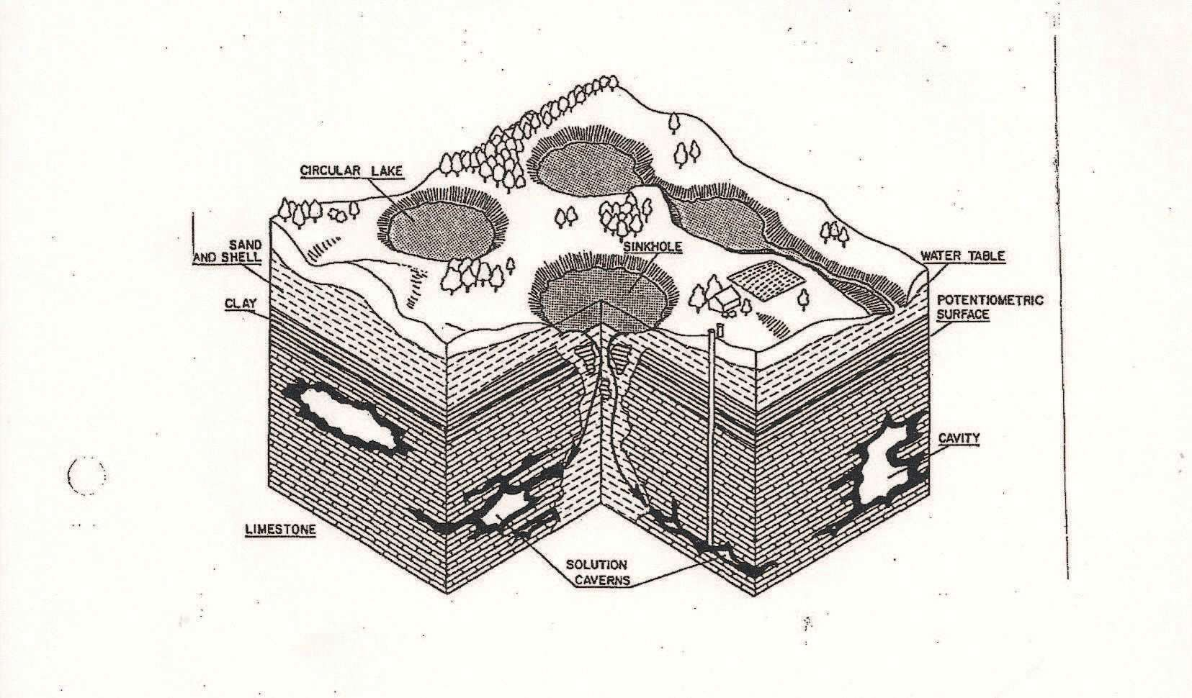

Water Use

Agriculture is the primary use of ground water in the Pierson area. Water is used for both irrigation and freeze protection. Freeze protection efforts have a particularly significant effect on the Floridan aquifer. During a prolonged freeze, pumping may drop the aquifer level as much as 50 feet in localized areas. However, full recovery of aquifer levels occurs within about two days. These dramatic fluctuations resulted in loss of water for many Pierson residents with shallow wells. This led the Town to construct a municipal water system supplied by two deep wells to eliminate the problems experienced by residents. It has also been the impetus to look for ways to reduce water usage for freeze protection

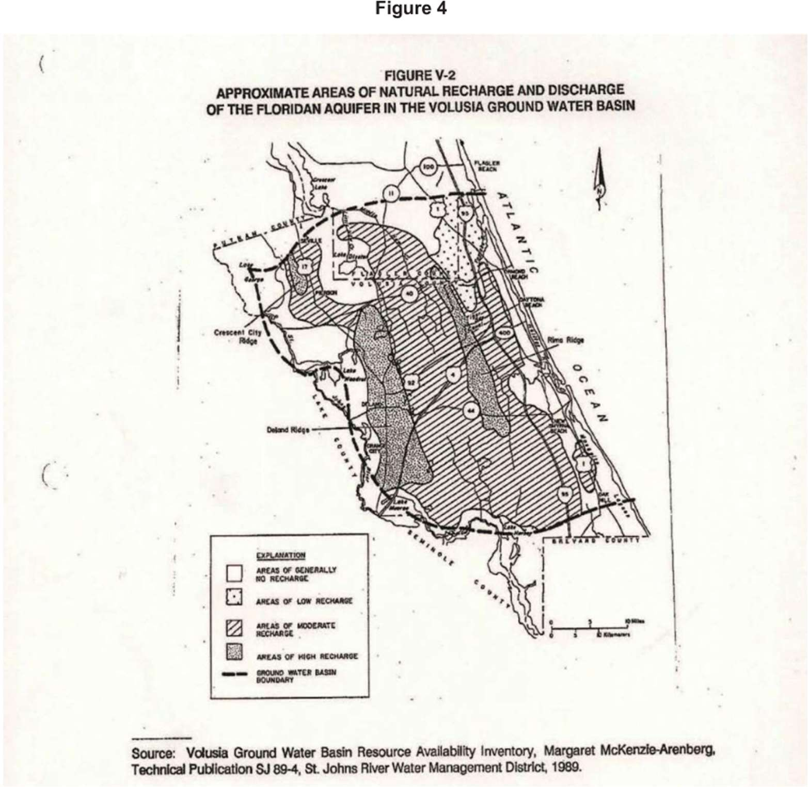

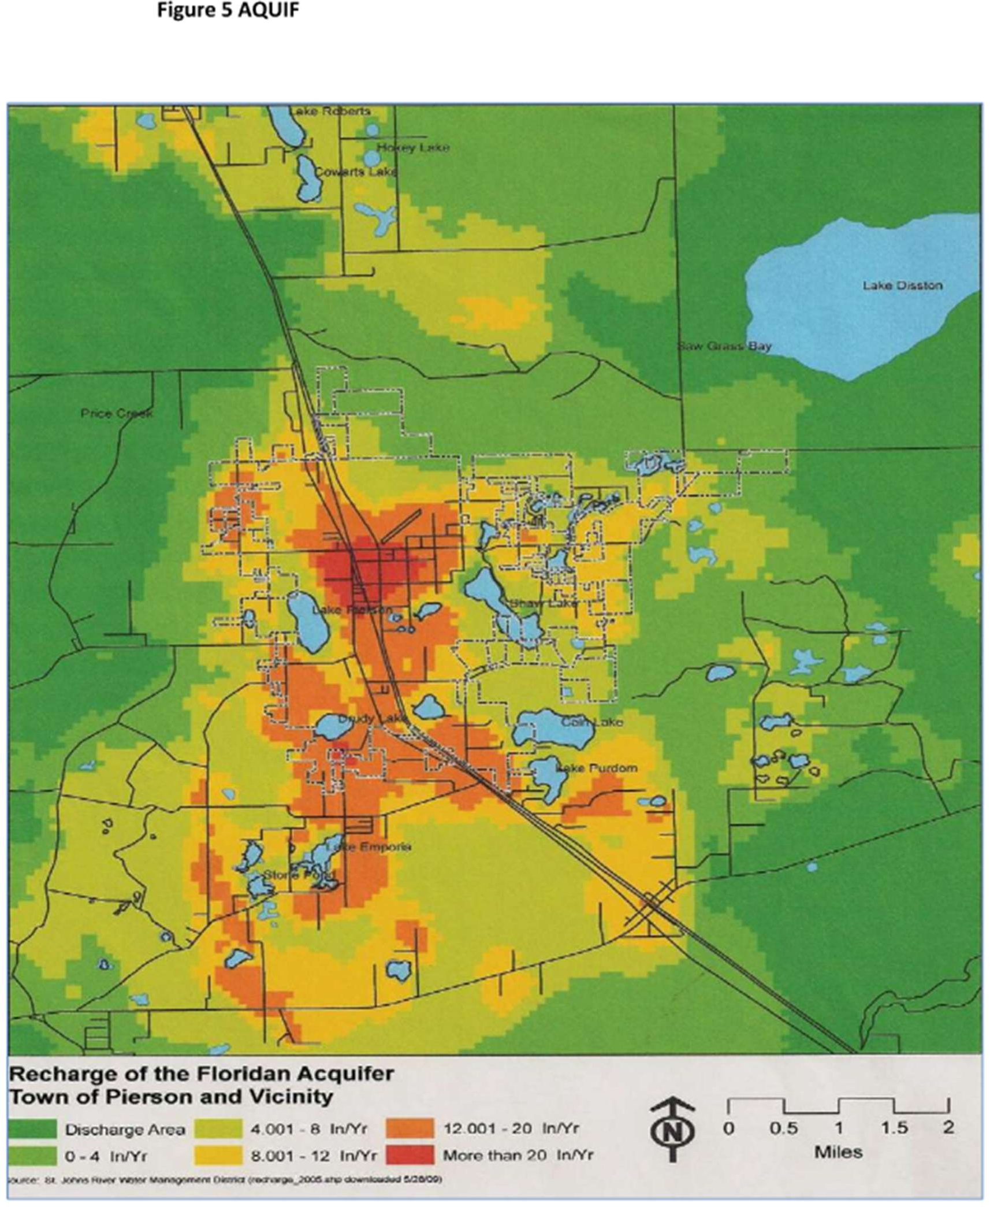

AQ Goal I: Protect aquifers that underlie the Town and its environs to the greatest extent possible.
AQ Objective I-1: On November 8, 2011 the Town updated its Land Development Regulations, by adding a new Section 8.5 High Aquifer Recharge Areas, to ensure: that land areas that are designated by the St. Johns River Water Management District as Floridan Aquifer high recharge areas are protected to the greatest extent possible subject to respecting private property rights. The Town shall enforce the provisions of Section 8.5 when reviewing development proposals in high recharge areas.
AQ Policy I-1.1: Concurrently, the Town shall also revise/update its Land Development Regulations for consistency with and support of Volusia County’s Goals, Objectives and Policies of Chapter 10, Natural Groundwater and Aquifer Recharge Element, of their Comprehensive Plan, to monitor, protect and enhance the Surficial and Floridian aquifers.
AQ Policy I-1.2: - When a development proposal may have a significant impact on the Floridian aquifer, the Town will consult both the Water Management District and the County for input in the development review process.

TOWN OF PIERSON COMPREHENSIVE PLAN 2040

CONSERVATION ELEMENT GOALS, OBJECTIVES AND POLICIES

CON Goal I: Conserve, protect, and restore natural resources in order to conserve and enhance vegetative communities, native habitats, wildlife diversity, and surface and groundwater quality and quantity.

CON Objective I-1.1: No land use or development that will degrade the quality of surface waters in and around Pierson shall be permitted by the Town.

CON Policy I-1.1: The Town shall require all new development to comply with the provisions outlined in its Unified Land Development Regulations, Article VII, Stormwater Management and Conservation, which provides that drainage from a site shall be "treated" to reduce the amount of pollutants to a that will degrade the ambient water quality of the receiving water body, when such information is available.

CON Policy I-1.2 - The Town shall require the preservation of natural upland vegetative buffers, a minimum of 25 feet in width, adjacent to wetland areas and surface water bodies and all other provisions as outlined in its Unified Land Development Regulations, Article VIII, Resource Protection.

CON Objective I-2: The Town shall through its Land Development Regulations provide for the protection, enhancement and management of significant natural vegetative communities in order to maintain their ecological, aesthetic, economic and recreational values.

CON Policy I-2.1: The Town's through its Land Development Regulations shall be require that an inventory of natural vegetative communities shall be provided by the applicant for all development proposals requiring site plan or plat approval. The applicant shall provide a plan for protection of species which are designated by either State or Federal agencies as endangered, threatened, or of special concern.

CON Policy I-2.2: Land Development Regulations revisions shall include provisions to preserve the upland buffers of native vegetation; significant habitat area (including wildlife corridors); scenic vistas; areas where native vegetation is important to impede erosion, and other areas where the public interest is best served by preserving native vegetation.

CON Policy I-2.3: Land Development Regulation revisions shall require that ecologically viable portions of natural upland plant communities including, but not limited to, rare or

endangered ecosystems within proposed urban development sites, should be preserved and maintained in their original state, to the greatest extent practicable.

CON Objective I-1.3: Maintain the existing characteristics of the groundwater aquifer, particularly with regard to the quantity and quality of water now found there.

CON Policy I-3.1: The Town shall continue to require new development to retain the "first inch" of rainfall on-site for eventual percolation into the groundwater aquifer.

CON Policy I-3.2: The Town shall promote preservation and replanting of natural vegetation in all development projects in an effort to curb the use of non-native, poorly adapted vegetation which requires excessive irrigation.

CON Policy I-3.3: Non-potable water use demands shall be met using water of the lowest quality supply which is both available and acceptable for the intended application. Water reuse or water reclamation programs should be used wherever economically and environmentally feasible to reduce groundwater withdrawals for water use applications which do not require potable water.

CON Policy I-3.4: The Town shall cooperate with the St. Johns River Water Management District and Volusia County to effectively implement within the town the emergency water conservation regulations enacted by the District and the County. In the event of a conflict the most restrictive regulations shall be implemented.

CON Objective I-4: Maintain or increase the current acreage of wetland vegetation located within the Town.

CON Policy I-4.1: No new developments shall be permitted to alter existing areas of wetlands vegetation except as necessary to allow reasonable use consistent with the Land Development Regulations. The definition of wetlands to be used for regulatory purposes by the Town, as defined in the Land Development Regulations and the appropriate federal and state agencies.

CON Policy I-4.2: For development projects below Water Management District permit thresholds, the Town shall continue to enforce, and periodically update as necessary, its requirements for wetland protection as stated in its Land Development Regulations and solicit technical assistance, when necessary, from an environmental consultant, county, regional, state and/or federal agencies.

CON Policy I-4.3: Land use planning and site design shall support development patterns which minimize the impact of development on wetland communities. As a result of development, there shall be no net loss of wetlands functions or values, nor shall wetlands functions and values be degraded

CON Policy I-4.4: The Town shall monitor development activity in and adjacent to wetland areas to ensure that existing local, state and federal wetland preservation requirements are strictly enforced and the permittee shall take positive steps to correct or mitigate any unnecessary degradation of water or wetland quality caused by site development as determined by St. Johns River Water Management District, the Florida Department of Environmental Protection, the Army Corps of Engineers, or the Town.

CON Policy I-4.5: Roadway designs in or near wetland areas will provide for the capture and diversion of stormwater runoff from roadway surfaces in wetland areas to upland stormwater retention/detention ponds for treatment prior to discharge into receiving water bodies.

CON Policy I-4.6: On-site wastewater treatment systems shall not be allowed within 75 feet landward of the upland/wetland interface or the 100-year floodplain boundary or within 120 feet of the shoreline edge, whichever is more restrictive.

CON Policy I-4.7: No wells shall be allowed to be constructed in wetlands.

CON Objective I-5: The Town, through its land use and development regulations shall ensure that development and redevelopment will not adversely affect the survival of threatened and endangered fish and wildlife.

CON Policy I-5.1: If it is presumed that a designated species may be present on the basis of general characteristics including the number and types of plant communities, the linear amount of "edge" such as the boundaries between woods and grasslands, the presence of water, and the presence of movement corridors between habitat areas, the Town shall require applicants for development to assess the impact of development on designated species. Designated species shall include those classified, by either the Florida Fish and Wildlife Conservation Commission or the U.S. Fish and Wildlife Service, as endangered, threatened, or species of special concern, or those species actively being considered for designation. When estimating the impact of proposed development, the applicant may be required to conduct an inventory of existing wildlife and vegetation on the site.

CON Policy I-5.2: Site development related activities shall not result in the harming, pursuit, or harassment of wildlife species classified as endangered, threatened or a species of special concern by either the State or Federal governments in contravention of applicable State or Federal laws. Should such species be determined to be residing on, or be otherwise significantly dependent upon the project site, the developer shall cease all activities which might negatively affect that individual or population and immediately notify the Florida Fish and Wildlife Conservation Commission or Florida Department of Environmental Protection, the United States Fish and Wildlife Service, and the City. Proper protection and habitat management, to the satisfaction of all agencies, shall be provided by the developer.

CON Policy I-5.3: Where a site is found to be inhabited by a gopher tortoise population that meets or exceeds the Florida Fish and Wildlife Conservation Commission's threshold of "significant" gopher tortoise habitat or which comprises part of a gopher tortoise population that may, in the aggregate, meet or exceed this threshold, the property owner shall protect such habitat areas through the use of conservation easements, deed restrictions, or common open space areas. As an alternative, gopher tortoises may be relocated only in conformance with an approved gopher tortoise relocation plan.

CON Objective I-6: Maintain the present high level of air quality in Pierson by preventing degradation of air quality below baseline standards established by the Florida Department of Environmental Protection (FDEP) and the U.S. Environmental Protection Agency.

CON Policy I-6.1: No industrial or commercial business which emits air pollutants that would degrade the Town’s ambient air quality will be permitted unless it they can demonstrate that all necessary air quality permits have been approved and all appropriate air pollution control devices and practices will be installed, prior to occupancy.

CON Policy I-6.2: The Town shall support, by Resolution, an inspection program by the Sheriff’s Office to identify vehicles which fail to meet pollution control standards as mandated by Florida Statutes.

CON Policy I-6.3: The Town shall encourage alternative modes of transportation by promoting the use of bicycles by building more bike lanes, bike paths, and bike racks, and requiring more improved pedestrian sidewalks.

CON Policy I-6.4: New facilities housing the young, the elderly or the handicapped shall be prohibited from locating near point air pollution sources and vice versa. Playgrounds and active recreation areas shall also be located a safe distance from these sources.

CON Policy I-6.5: Construction, excavation, and land clearing activities shall minimize the exposed ground surface area. Any area that is to be exposed for an extended time period shall be mulched or sodded

CON Objective I-7: The Town shall continue to enforce its wellfield protection requirements of its Land Development Regulations to protect potable water wells located within the Town's jurisdiction from contamination by threatening activities, request assistance from the Water Management District to determine the actual extent of the cones of influence and revise its Land Development Regulations in light of new data.

CON Policy I-7.1: In the absence of scientific data and analysis identifying the actual extent of the cones of influence surrounding potable water wells, the Town adopted as

a part of its Unified Land Development Regulations, Well Field Protection standards, patterned after Volusia County’s Minimum Standards for Potable Water Well Field Protection Land Development Regulations defines a “Primary Well Field Protection Zone” immediately surrounding any potable water supply well and extending a radial distance of two-hundred (200) feet. The “Primary Well Field Protection Zone” is established as a zone of exclusion, where no development will be permitted. A “Secondary Well Field protection Zone” surrounds the Primary Well Field protection Zone and extends a radial distance of eight-hundred (800) feet from the Primary Well Field protection Zone. Within the Secondary Well Filed Protection Zone, the following land uses are prohibited:
  - Landfills;
  - Facilities for the bulk storage, handling or processing of materials on the Florida Substance List;
  - Activities that require the storage, use or transportation of restricted substances, toxic or hazardous materials, agricultural chemicals, petroleum products, hazardous toxic waste, medical waste, etc.;
  - Feedlots or other commercial animal facilities;
  - Wastewater treatment plants, percolation ponds, and similar facilities;
  - Mines; and
  - Excavation of waterways or drainage facilities which intersect the water table.

The Primary and Secondary Well Field Protection Zones are shown on the Town’s Official Zoning Map and this plan’s Future Land Use Map.

CON Policy I-7.2: At such time funding becomes available, the Town shall request the assistance of the St. Johns River Water Management District to perform a scientific study to determine the actual extent of the cones of influence. When such a study is completed, the Town shall amend the Comprehensive Plan’s Future Land Use Map and the Official Zoning Map to show the approximate locations of the new zones. The land uses to be allowed within these protection zones will be evaluated and revised, if necessary, based on the results of the study.

CON Objective I-8: The Town shall enforce the provisions of its Land Development Regulations related to High Recharge Areas of Land Development Regulations to ensure that land areas that are designated by the St. Johns River Water Management District as Floridian Aquifer high recharge areas are protected to the greatest extent possible subject to respecting private property rights.

CON Policy I-8.1: Concurrently, the Town shall also revise/update its Land Development Regulations for consistency with and support of Volusia County’s Goals, Objectives and Policies of Chapter 10, Natural Groundwater and Aquifer Recharge Element, of their Comprehensive Plan, to monitor, protect and enhance the Surficial and Floridian aquifers.

CON Policy I-8.2: When a development proposal may have a significant impact on the Floridian aquifer, the Town will consult both the Water Management District and the County for input in the development review process.

CON Goal II: The Town shall continue to implement current programs and study and adopt new programs to minimize public and private losses and threats to public health, safety and welfare due to flood conditions and hazards.

CON Objective II-1: Flood damage prevention shall be accomplished through restricting new development from obstructing the flow of water and increasing flood heights within a floodplain. To offset any loss of flood storage capacity, compensatory storage is required for new fill, or other obstruction, put in the floodplain by providing an at least equal volume to replace the lost flood storage volume.

CON Policy II-1.1: The Town shall protect the natural functioning values of the floodplains to the maximum extent feasible through wetland buffer requirements, compensatory storage, conservation easements and tree protection ordinances.

CON Policy II-1.2: The Town shall require all new development occurring within the 100- year floodplain to provide for the protection of adjacent properties.

CON Policy II-1.3 - The Town shall regulate the deposition of fill material within a floodway in order to prevent damage to the public by posing a threat to life and property in excess of that anticipated by the 100-year storm in the floodway fringe areas.

CON Policy II-1.4 - Sites for the creation of compensatory storage volume, commensurate with any flood storage volume lost as a result of development activities (including roadways) in the 100-year floodplain, shall be on the same or adjacent site or within the same hydraulically connected basin in order to provide for effective storage volume within the floodplain, but shall not be located within land areas within the jurisdictional wetland limits of regulatory agencies, except for the purpose of providing pretreated stormwater storage capacity. Special Flood Hazard Areas shall be interpreted as that portion of the site lying within the boundaries of the 100-year floodplain based on the Official Federal Emergency Management Agency Flood Insurance Study and corresponding Flood Insurance Rate Maps, FIRM’s.

CON Policy II-1.5 - The Town shall ensure that fill material or other structures do not adversely obstruct the movement of floodwaters natural overland sheet flow or pose a threat to the public health, safety, and welfare.

CON Policy II-1.6 - Areas not filled within the floodplain are to be generally left in their natural state. However, such areas may be used to meet landscaping and/or retention

requirements, provided that the design of development is consistent with Town codes and standards.

CON Objective II-2: The Town shall, update its Land Development Regulations shall implement of the Goals, Objectives and Policies of this Element related to flood plains.

CON Policy II-2.1: The Town shall continue to develop and enforce a floodplain management program that balances the public interest in regulating the use of private property against the interests of private landowners.

CON Policy II-2.2: The Town shall continue to participate in the National Flood Insurance Program.

CON Policy II-2.3: The Town shall periodically review its zoning regulations to ensure that the density which is permitted under each zoning category is consistent with the Town’s desire to protect the natural functioning values of the floodplain and to protect the quality and quantity of surface water resources.

CON Policy II-2.4: Floodplains whose functional values have been degraded or destroyed through human intervention should be restored, if possible, by acquisition of historic floodplain lands. Various state, regional and local land acquisition programs shall be used for this purpose.

CON Policy II-2.5: The Town shall periodically amend its flood plain regulations to incorporate recently updated flood insurance studies and flood insurance rate maps and to further bring it into full compliance with revisions of the national flood insurance program floodplain management criteria.

CON Policy II-2.6: All new public buildings and infrastructure shall be located outside the 100-year floodplain to the maximum extent feasible. Appropriate flood proofing measures shall be undertaken for any public buildings located within the floodplain. Any pump stations or other electrical and mechanical equipment shall be designed to be protected from physical damage by the 100-year flood. The Town shall coordinate its floodplain management programs with appropriate Federal, State, regional, and local governments.

CON Goal III: For new development and redevelopment, apply better site design and low impact development (LID) techniques, and pursue commitments to reduce stormwater runoff volumes and peak flows, to increase groundwater recharge and to increase preservation of undisturbed areas.

CON Objective III-1: The Town through its Land Development Regulations, shall implement Low Impact Development techniques.

CON Policy III-1.1: LDR revisions should include integration of the source control concept which places a greater importance on managing smaller, cost-effective landscape features located on each lot rather than through costly pipe and pond stormwater management design.

CON Policy III-1.2: Maintain or improve infiltration, frequency and volume of discharges, and groundwater recharge by placing greater emphasis on reducing pervious surfaces, functional grading, open channel sections, and the increase use of bio-retentional filtration landscaped areas.

CON Policy III-1.3: Integrate alternative stormwater management practices such as on- lot micro-storage, functional landscaping, open drainage swales, reduced imperviousness, flatter grades, increased runoff travel time, and depression storage into a multifunctional site design.

CON Policy III-1.4: Reduce the use of centralized best management practices (BMPs) such as stormwater ponds through the use of Integrated Management Practices (IMPs) which are distributed in small portions of a lot or parcel and near the source of impacts.

CON Policy III-1.5: Amend the LDC and Construction Details to permit LID designs that can significantly reduce development costs through smart site design by:
- Reducing impervious surfaces (roadways), curb, and gutters;
- Decreasing the use of storm drain piping and inlet structures; and
- Eliminating or decreasing the size of large stormwater ponds.

CON Goal IV: Preserve archeological and historic resources in and within close proximity to the Town to protect this heritage for current and future residents.

CON Objective IV-1: The historical structures identified by the Department of State, Division of Historical Resources on their Master Site File and the potential archeological area south and east of the Town shall be protected to the greatest extent possible.

CON Policy IV-1.1: Encourage future development and redevelopment activities in the areas surrounding the historical structures identified on the Master Site File to be similar in architectural character to ensure a reasonable degree of compatibility.

CON Policy IV-1.2: The Town shall encourage owners of historical structures to seek inclusion of their structure in the National Register of Historic Places.

CON Policy IV-1.3: The Town shall develop incentives to encourage adaptive reuse of historic structures in a manner that will preserve the historic value of such structures.

CON Policy IV-1.4: With voluntary assistance from historians and archaeologists as may be available, the Town shall continue to identify and preserve significant historic structures and archeological sites.

TOWN OF PIERSON COMPREHENSIVE PLAN 2040

RECREATION AND OPEN SPACE GOALS, OBJECTIVES AND POLICIES

REC Goal I: Provide a high level of active and passive recreational opportunities for the residents of Pierson.

REC Objective I-1: Maintain a system of recreation and open space that meets the existing and future recreational needs of the residents of the Town.

REC Policy I-1.1: The Town shall continue to review development proposal in conjunction with its concurrency management system to assess their impacts on present or proposed recreational or open space areas based on the following level of service standards:

Equipped tot Lot: .5 acres per 1,000 population Neighborhood Parks: 1.9 acres per 1,000 population Community Parks: 2.0 acres per 1,000 population

REC Policy I-1.2: No development shall be permitted by the Town if the resulting impact will exceed the capacity of the existing open space and recreation facilities.

REC Policy I-1.3: The Town shall maintain and expand existing Town-owned open space and recreational facilities through proper management techniques funded from the Town's operating budget and other available sources.

REC Objective I-2: The Town shall seek funding from all available sources to acquire land and develop new recreational facilities.

REC Policy I-2.1: Depending on the availability of funding, the Town shall apply for grants under the Florida Recreation Development Assistance Program, FRDAP, for the purpose of funding the acquisition and development of new recreation and open space facilities.

REC Policy I-2.2: The Town shall continue to fund anticipated operational and maintenance costs in order to ensure that the site and facilities provide long, and satisfying service to all users.

REC Policy I-2.3: The Town will utilize all available funding sources to expand existing and provide new recreation and open space facilities, those funding sources include but are not limited to state and County grant funds; user fees and developer contributions in lieu of land and/or facility development on site.

REC Objective I-3: The Town shall begin negotiations to establish interlocal agreements with Volusia County, the Volusia County School Board, the Water Management District other public agencies and the private sector, as may be appropriate, to further develop recreational opportunities for Pierson residents using existing recreation areas and facilities and unused lands owned by such entities.

REC Policy I-3.1: Maximum use of existing recreation areas and facilities shall be encouraged.

REC Policy I-3.2: Cooperative arrangements between the City and other public or private entities for purchase, development, management and/or maintenance of recreation areas and facilities shall be encouraged when such arrangements will provide an efficient, economical means of meeting the recreational needs of Pierson residents.

REC Policy I-3.3: The Town shall investigate the feasibility of utilizing incentives for the development of recreation and open space facilities within projects that are of such a scale where incentives are feasible.

TOWN OF PIERSON COMPREHENSIVE 2040 INTERGOVERNMENTAL COORDINATION ELEMENT GOALS, OBJECTIVES AND POLICIES
ICE Goal I: Coordinate the Pierson Comprehensive Plan and its implementation with the plans and policies of other governments and agencies to maximize the impact and effectiveness of each plan.
ICE Objective I-1: Pierson shall coordinate its plan with the plans of Volusia County and other municipalities and the Volusia County School Board.
ICE Policy I-1.1: Pierson shall submit plan amendments to the Volusia Growth Management Commission, VGMC, to ensure consistency with the plans of Volusia County and other municipalities.
ICE Policy I-1.2: Pierson shall provide a copy of its proposed plan amendments to Volusia County prior to adoption by the Town Council.
ICE Policy I-1.3: Pierson representatives shall use regular attendance at the River to Sea Transportation Planning Organization meetings to coordinate transportation planning.
ICE Policy I-1.4: Pierson shall provide a copy of proposed plan amendments to the Volusia County School Board.
ICE Policy I-1.5: Pierson shall request an opportunity to review and comment on the plans of Volusia County and the Volusia County School Board
ICE Objective I-2: Continue to coordinate Pierson's plan with development in the unincorporated county and the plans of the region and the state.
ICE Policy I-2.1: Pierson shall continue to coordinate with Volusia County its review of development proposals in the adjacent unincorporated area.
ICE Policy I-2.2: Pierson shall provide Volusia County an opportunity to comment on any comprehensive planning action proposed by Pierson.
ICE Policy I-2.3: Pierson shall continue to support and cooperate with the East Central Florida Regional Planning Council.
ICE Policy I-2.4: Where its interests are affected, Pierson shall participate in public hearings and informational meetings sponsored by other local governments and regional and state agencies
ICE Objective I-3: Pierson shall continue to require approvals of development plans from external agencies the Town has specified in its development regulations.
ICE Policy I-3.1: Development orders, including development plan approvals and issuance of Certificates of Occupancy, may not be issued until any required outside agencies approvals have been obtained.

ICE Policy I-3.2: Pierson shall continue to state, enforce and update as necessary in its development review forms and procedures that certain required approvals from outside agencies must be obtained prior to the Town’s approval.
ICE Objective I-4: Pierson shall coordinate its designated levels of service with other governments providing service to the Town.
ICE Policy I-4.1: Pierson shall coordinate with level of service for solid waste disposal with Volusia County.
ICE Policy I-4.2: The Florida Department of Transportation shall be advised of the local level of service designated for state roads in the Town.
ICE Policy I-4.3: Pierson shall continue to coordinate with the County the enforcement of its minimum performance standards for environmental protection.
ICE Objective I-5: Pierson shall continue to be represented on local policy or technical committees which act to coordinate planning or plan implementation effort
ICE Policy I-5.1: Pierson shall closely coordinate with the St. Johns River Water Management District by monitoring proposed district rules, cooperating with district programs of benefit to the Town, and comments on district activities at regular district meeting and public hearings.
  - The Town will main a water supply facilities work plan that is coordinated with the SJRWMD’s Water Supply Plan by updating the work plan and related Comprehensive Plan policies within 18 months of an update to SJRWMD’s Water Supply Plan that effects the Town. The work plan shall identify alternative water supply projects and traditional water supply projects and conservation and reuse necessary to meet existing and new development water needs.
  - The Town will participate in the development of updates to SJRWMD’s water supply assessment and Water Supply Plan and other water supply development-related initiatives facilitated by SJRWMD that affect the Town.
ICE Policy I-5.2: Pierson shall continue to be represented on the Zone 4 Impact Fee Advisory Committee to coordinate road construction actions and priorities.
ICE Policy I-5.3: Pierson shall continue to have a representative serve on the Volusia Growth Management Commission and to support their efforts at coordinating planning activities in Volusia County.
ICE Policy I-5.4: The Town shall continue to work with Federal Home Administration and Volusia County to develop a coordinated program for the delivery of housing assistance.
ICE Objective I-6: Pierson shall establish a program for resolving intergovernmental conflicts.
ICE Policy I-6.1: The Town shall meet with representatives from the other affected parties to attempt to negotiate a resolution to any conflict.

ICE Policy I-6.2: Where no local resolution can be obtained, the Town shall apply the mediation process available through the East Central Florida Regional Planning Council.
ICE Goal II: Establish and maintain a cooperative relationship between the Town of Pierson and School District to provide an effective joint planning process including procedures to coordinate land use planning with the development of school facilities including public school siting, calculate population projections, and provide for the development of public education facilities concurrently with residential development and other public facilities and services.
ICE Objective II-1: Intergovernmental Coordination. The Town of Pierson shall establish coordination mechanisms with the School Board to achieve a collaborative effort to identify school needs, provide for school facilities and implement school concurrency using consistent supporting data and analysis
ICE Policy II-1.1: In cooperation with the School Board, the Town of Pierson shall adopt and implement the interlocal agreement as required by Section 1013.33 F.S., which includes procedures for:
- Coordinating and sharing information
- Educational and ancillary siting procedure
- Comprehensive plans and plan amendment review
- Site design and development plan review
- Joint development of schools, parks and other uses
- School concurrency implementation
- Implementation and amendments
- Resolution of disputes
ICE Policy II-1.2 - In accordance with the schedule established in the interlocal agreement, the Town of Pierson shall appoint a representative to meet with School Board and other local government representatives to review data and annually approve a projection of the amount, type, and distribution of population growth and student enrollment. Data shall include but not be limited to:
- Capital budgets for each jurisdiction
- School Board five-year facilities work program
- School Board educational plant survey (every fifth year)
- Volusia County five-year road improvement program
- Anticipated new development, infill development and redevelopment
- Student enrollment and school utilization including portable classroom assignment
ICE Policy II-1.3 - Town of Pierson shall provide the School Board with a copy of each planning board and Commission agenda.
ICE Policy II-1.4 - The Town of Pierson and the School Board shall coordinate the acquisition and development of sites for future educational and ancillary facilities in accordance with the process established in the interlocal agreement.

ICE Policy II-1.5: The Town of Pierson shall provide notice to adjacent jurisdictions as required by the Volusia County Interlocal Agreement for School Planning when school capacity in the adjacent jurisdiction is anticipated to be applied to meet concurrency requirements for proposed residential development.

TOWN OF PIERSON COMPREHENSIVE PLAN 2040

CAPITAL IMPROVEMENTS ELEMENT GOALS, OBJECTIVES AND POLICIES

CIE Goal I: To provide and maintain capital improvements in a timely and cost efficient manner, and in a manner that assigns the costs of such improvements fairly and equitably which are needed to protect the health safety and welfare of the public and achieve acceptable levels of service.
CIE Objective I–1: The Town shall use the Capital Improvement Element to correct existing deficiencies, to accommodate desired growth, and to replace worn-out and obsolete facilities, in accordance with the 5-year schedule of capital improvements.
CIE Policy I-1.1: The town shall include capital improvements determined to be of relatively large scale and high cost ($10,000 or greater) within the 5-year schedule of capital Improvement projects of this element.
CIE Policy I-1.2: First priority shall be given to those projects that are intended to maintain, upgrade, repair or replace existing facilities.
CIE Policy I-1.3: The following criteria shall be used as the basis for prioritizing expenditures for capital improvements (in order of highest to lowest priority):
  - Needed for protection of the public health or a safety problem;
  - Needed for protection of the environment;
  - Needed to secure a public investment;
  - Needed to match funds form an outside source;
  - Needed to accommodate new development and redevelopment consistent with the Comprehensive Plan;
CIE Policy I-1.4: Capital facilities shall be regularly inspected, and replacement or renewal shall be scheduled so that level of service standards are maintained.
CIE Policy I-1.5: The Town shall coordinate transportation Improvements with Florida Department of Transportation, local and regional plans, and work with other entities to try to acquire advanced rights-of-way for transportation projects as funds are available.
CIE Policy I-1.6: The town shall comply with current Florida Department of Transportation criteria for access management and rights-of-way acquisition for long range transportation projects on State roadways, including notification of the Department of Transportation when proposed development orders would interfere with future right-of- way needs of the Department.
CIE Objective I–2: The Town shall continue to implement its concurrency management system to ensure future development will bear a proportionate cost of facility improvements necessitated by the development in order to maintain the adopted LOS standards.

CIE Policy I–2.1 – Prior to approval of a building permit or its functional equivalent, the Town determines whether adequate water supplies will be available to serve the new development no later than the anticipated date of issuance of a certificate of occupancy. The town shall consider information such as the current potable water demand, including capacity for approved projects not yet built, the amount of water necessary to meet the growth projections for the year; the amount of water withdrawals allowed and remaining through the consumptive use permit issued by the water management district; the capacity of available facilities; and any capital improvements schedule projects scheduled to come online during the development time frame of the project.
CIE Policy I–2.2 – All applications for future land use map amendments that would permit a potential increase in intensity or density of development will be required to provide data and analysis to demonstrate that adequate water supply and adequate public water facilities will be available for future population water demand associated with the land use map amendment.
CIE Policy I–2.3: The Town shall continue to require construction of roads, drainage structures and other necessary infrastructure improvements as a condition of subdivision plat approval.
CIE Policy I–2.4: The Town shall consider alternative ways to allocate the costs of new public facilities on the basis of the benefits received by existing and future residents.
CIE Objective I–3: The Town shall manage its fiscal resources to ensure the provision of needed capital improvements for previously issued development orders and for future development and redevelopment.
CIE Policy I–3.1: Prior to issuing certificates of occupancy, the Town shall provide for all public facilities needed to serve development for which development order were previously issued.
CIE Policy I–3.2: In providing capital improvements financed by general obligation bonds, the Town shall limit the ratio of debt service to no more than 15 percent of General Fund revenues.
CIE Policy I–3.3: As part of the annual budget process, the Town shall evaluate capital facility costs and available development impact methodologies to consider enacting an ordinance requiring payment of capital facility impact fees at the time of subdivision plat
CIE Policy I–3.4: As part of the annual budget process, the Town shall review the cost of paving and consider establishing one or more special assessment districts to fund local road paving.
CIE Policy I–3.5: The Town shall continue strong efforts to secure grants for capital improvements.
CIE Policy I–3.6: Long-term borrowing shall not be used to finance current operations or normal maintenance.

CIE Policy I–3.7: Lease-purchase methods, bonds or other debt instruments may be used as a medium-term (4 to 10 years) method of borrowing for the financing of vehicles, other specialized types of equipment, or other capital improvements. The Town shall determine and utilize the least costly financing methods available. Such debt arrangements will be repaid within the expected life of the equipment or improvement acquired.
CIE Policy I–3.8: General obligation bonds, which require referendum, may not be used for any enterprise fund public facilities, except where the Town Council deems such action to be in the public interest to protect the health, safety and welfare of the community.
CIE Policy I–3.9: The term of any debt issues shall not exceed the life expectancy of the capital improvement it is financing.
CIE Policy I–3.10: Sale of revenue bonds shall be limited to that amount which can be supported from fees or other revenues not required to support General Fund operations.
CIE Objective I–4: Decisions regarding the issuance of development order and permits and available revenues shall be coordinated with the Town’s 5-year schedule of capital improvements to maintain the adopted LOS standards.
CIE Policy I-4.1: The Town has adopted and shall adhere to the following LOS standards in reviewing the impacts of new development and redevelopment upon public facilities:
Traffic Circulation
Collector Roads LOS C at peak hour
Minor Arterial Roads LOS C at peak hour
Principal Arterial Roads LOS C at peak hour
Sanitary Sewer Services Applicable standards of the Florida Department
of Health and Rehabilitative Services for onsite sewage disposal systems
Potable Water Service 56 gallons per capita a day Solid Waste Collection
and Disposal Service 1.8 pounds per capita per day

Stormwater Management First inch of rainfall shall be retained; discharge
hydrograph for post development conditions shall be maintained within 10%, in terms of peak flow and total volume, of the predevelopment conditions; peak discharge form post development conditions shall not exceed peak discharge from predeveloped conditions for 100 year frequency storm of 24 hour duration.

Open Space and Recreation

Equipped Tot Lot .5 acres per 1,000 population

Neighborhood Parks 1.9 acres per 1,000 population

Community Parks 2 acres per 1,000 population Schools (Per adopted PSFE, 2008)
Elementary Schools: 115% of permanent FISH capacity for the concurrency service area

K-8 Schools: 115% of permanent FISH capacity for the concurrency service area.

Middle Schools: 115% of permanent FISH capacity for the concurrency service area

High Schools: 120% of permanent FISH capacity for the concurrency service area

Special Purpose Schools: 100% of permanent FISH capacity

CIE Policy I-4.2: The Town has adopted development regulations that include a concurrency management system to ensure that adequate public facilities and services are available to accommodate new development and redevelopment and that the adopted LOS standards are maintained. Specifically, the concurrency management system includes the following provisions:

- All applications for development orders shall demonstrate that the proposed development does not degrade adopted levels of service in the Town.
- The latest point at which compliance is determined is the final development order. If no development order is required, the latest point to determine concurrency is the first development permit on a site. In no event shall the determination of concurrency be made later than the point when a specific plan for development, including densities and intensities of development, is approved or when construction or physical activity on the land is authorized if a specific plan is not involved.
  - If a development order or permit is approved prior to authorization of construction or physical activity on the land, the approval must be conditioned upon the availability of adequate public facilities and services to serve the development prior to final approval to proceed with construction or physical activity.

- For purposes of concurrency management the available capacity of a facility shall be determined by:
  - Adding together the following:
    - The total capacity of existing facilities;
    - The total capacity of new facilities, if any, that will become available or before the date of occupancy of the development. Public facility capacity shall be determined as available for potable water, sanitary sewer, solid waste, and drainage if it meets any of conditions A through C below. Park and recreation capacity shall be determined as available if any of conditions A through D are met. Road capacity shall be determined as available if any of the conditions (a) through
(e) are met.
- The facility/service is in place to serve a proposed project at the time that a development order is approved.
- The facility/service will be in place at the time of project impact.
- The facility is under construction at the time that a development order is approved.
- The facility/service is the subject of a binding executed construction contract that provides for the commencement of the actual construction of the required facilities within one year of the issuance of the development order.
- In the case of road facilities, construction of such road facilities is scheduled to commence within the first three years of the five-year schedule of capital improvements in the adopted Capital Improvements Element or within the first three years of the approved five-year plan of the Florida Department of Transportation.
  - Subtracting From That Number the Sum Of:
- The demand for the service or facility created by existing development as documented in the Town’s Comprehensive Plan; and
- The demand for the service or facility crated by the anticipated completion of other approved developments, redevelopment, or other development activity.
- Where applicable capacity cannot be shown, the following methods may be used to maintain adopted level of service:
  - The project owner or developer may provide the necessary improvements to maintain level of service.
  - The proposed project may be altered such that projected level of service is no less than the adopted level of service.
  - The Town may approve the development order with conditions agreeable to both the Town and the developer. Such conditions shall be sufficient to ensure that the impact of the development will not degrade the level of service of any facility to a point below the adopted level of service standard for such facility.

- A determination of compliance with the provisions of this section shall be valid for as long as the development order on which the determination was based shall remain valid.
- If it is determined that adequate capacity is available for a proposed development, a Certificate of Capacity shall be issued for such development.
- The following types of facilities and services shall be review for adequacy before issuing a certificate of capacity; roads, sanitary sewer, solid waste, drainage, potable water, and recreation.
- For those projects listed in the five year capital improvement program which are needed to maintain adopted level of services standards, a comprehensive plan amendment shall be required to eliminate, defer or delay the construction or provision of the facility or service involved.

CIE Policy I–4.3: Before new development or redevelopment is authorized to proceed, the town shall require that public facilities and services needed to support the impacts of development or redevelopment are adequate. Public facilities and services needed to accommodate a development or redevelopment may be phased, or the development or redevelopment may be phased, so that the public facilities and services are adequate concurrent with the impacts of development or redevelopment.

CIE Goal II: Provide for a financially feasible public school facilities program.

CIE Objective II-1: Level of Service Standards. The Town of Pierson shall ensure that the capacity of schools is sufficient to support residential subdivisions and site plans at the adopted level of service standard. This level of service standard shall be consistent with the level of service standard adopted in the interlocal agreement entered into by the School Board and local governments with Volusia County.
CIE Policy II–1.1: The level of service standard adopted by Town of Pierson shall be applied consistently by all local governments within Volusia County and by the School Board district-wide to all schools of the same type.
CIE Policy II–1.2 – Consistent with the interlocal agreement, the uniform, district-wide level of service standards are set as follows using FISH capacity based on the traditional school calendar:
- Elementary Schools: 115% of permanent FISH capacity for the concurrency service area
- K-8 schools: 115% of permanent FISH capacity for the concurrency service area
- Middle Schools: 115% of permanent FISH capacity for the concurrency service area
- High Schools: 120% of permanent FISH capacity for the concurrency service area
- Special Purpose Schools: 100% of permanent FISH capacity

CIE Objective II–2: School Capital Facilities Planning
The Town of Pierson shall cooperate with the School Board to ensure existing deficiencies and future needs are addressed consistent with adopted level of service standards for public schools.
CIE Policy II–2.1: As part of its annual budget process, the Town of Pierson shall adopt as part of its Capital Improvements Element the Volusia County School District five year work program approved in September of each year as part of the School District budget, including planned facilities and funding sources to ensure a financially feasible capital improvements program and to ensure the level of service standards will be achieved by the end of the five year period.
CIE Policy II–2.2: The Town of Pierson shall coordinate with the School Board and adopt development conditions to ensure that future development pays a proportionate share of the costs of capital facility capacity needed to accommodate new development and to assist in maintaining the adopted level of service standards via impact fees and other legally available and appropriate methods.

Town of Pierson Comprehensive Plan 2040

Public Schools Facilities Element Goals, Objectives and Policies

PS Goal I: Collaborate and coordinate with the School Board of Volusia County to provide and maintain a public education system which meets the needs of Volusia County’s current and future population.

PS Objective I-1: Coordination and Consistency. The Town of Pierson shall implement and maintain mechanisms designed to coordinate with the School Board to provide consistency between local government comprehensive plans and public school facilities and programs.

PS Policy I-1.1: Pursuant to the procedures and requirements of the adopted interlocal agreement, the Town of Pierson shall coordinate with the School Board on growth and development trends, general population and student projections to ensure that the plans of the School Board and the Town of Pierson are based on consistent data.
PS Policy I-1.2: The Town of Pierson shall provide the representative with copies of all meeting agendas and staff reports.

PS Objective I-2: School Facility Siting and Availability. The Town of Pierson shall coordinate with the School Board on the planning and siting of new public schools and ancillary facilities to ensure school facilities are coordinated with necessary services and infrastructure and are compatible and consistent with the comprehensive plan.

PS Policy I-2.1: The Town of Pierson shall coordinate with the School Board to assure that proposed public school facility sites are consistent with the applicable land use categories and policies of the comprehensive plan. Schools shall be permitted in all future land use classifications except for the Heavy Commercial and Industrial Use and Recreation Land Use classifications.

Future Land Use Categories

Agriculture and Rural Residential Schools Permitted Low Density Residential Schools Permitted
Medium Density Residential Schools Permitted Medium Density Mobile Home Schools Permitted High Density Residential Schools Permitted
General Retail Commercial Schools Permitted

General Retail Commercial Schools Permitted (Low Intensity)

Heavy Commercial & Industrial Schools Not Permitted Public/Institutional Schools Permitted
Recreation Land Schools Not Permitted

PS Policy I-2.2: Coordination of the location, acquisition, phasing and development of future school sites and ancillary facilities shall be accomplished through the procedures adopted in the interlocal agreement.
PS Policy I-2.3: The Town of Pierson and School Board will jointly determine the need for and timing of on-site and off-site improvements necessary to support each new school or the proposed renovation, expansion or closure of an existing school. If deemed necessary, the parties may enter into a written agreement as to the timing, location, and party or parties responsible for constructing, operating and maintaining the required improvements.

PS Policy I-2.4: The Town of Pierson shall encourage the School Board to land bank sites for future use as school facilities. The Town of Pierson shall coordinate with the School Board on the acquisition and use of land banked sites in the same manner as established for other sites in order to ensure adequate infrastructure is planned and constructed in advance of school construction.

PS Policy I-2.5: The Town of Pierson shall protect schools and land banked school sites from the adverse impact of incompatible land uses by providing the School District with the opportunity to participate in the review process for all proposed development adjacent to schools.

PS Policy I-2.6: In developing capital improvements plans and programs for public services, the Town of Pierson shall consider required infrastructure to service existing and proposed schools and any land banked school sites.

PS Objective I-3: Enhance Community Design. The Town of Pierson shall enhance community and neighborhood design through effective school facility design and siting standards and encourage the siting of school facilities in order to serve as community focal points and are compatible with surrounding land uses.

PS Policy I-3.1: The Town of Pierson shall coordinate with the School Board on opportunities for the expansion and rehabilitation of existing schools so as to support neighborhoods and redevelopment.

PS Policy I-3.2: The Town of Pierson shall collaborate with the School Board on the siting of public facilities such as parks, libraries, and community centers near existing or planned public schools, to the extent feasible.

PS Policy I-3.3: The Town of Pierson shall look for opportunities to co-locate and share the use of public facilities when preparing updates to the comprehensive plan’s schedule of capital improvements and when planning and designing new or renovating existing, community facilities. Co-located facilities shall be governed by a written agreement between the School Board and the Town of Pierson specifying operating procedures and maintenance and operating responsibilities.

PS Policy I-3.4: The Town of Pierson shall reduce hazardous walking conditions consistent with Florida’s safe ways to school program. In conjunction with the School Board, the Town of Pierson shall implement the following strategies:

- New developments adjacent to schools shall be required to provide a right- of-way and direct safe access path for pedestrian travel to existing and planned schools and shall connect to the neighborhood’s pedestrian network.
- New development and redevelopment within two miles of a school shall be required to provide sidewalks within or adjacent to the property for the corridor that directly serves the school or qualifies as an acceptable designated walk or bicycle route to the school.
- In order to ensure continuous pedestrian access to public schools, the Town of Pierson shall consider infill sidewalk and bicycle projects connecting networks serving schools as part of the annual capital budget process. Priority shall be given to hazardous walking conditions pursuant to Section 1006.23, Florida Statutes.
- The Town of Pierson shall coordinate with the Metropolitan Planning Organization to maximize the funding from the Florida Department of Transportation and other sources that may be devoted to improving pedestrian networks serving schools.
PS Policy I-3.5: The Town of Pierson and School Board shall coordinate with Volusia County Emergency Services on efforts to build new school facilities, and facility rehabilitation and expansion, to be designed to serve as and provide emergency shelters as required by Section 1013.372, Florida Statutes.

PS Objective I-4: Coordinate Comprehensive Plan Amendment and Development Orders with School Capacity
Manage the timing of new development to coordinate with adequate school capacity as determined by the Volusia County School District.

PS Policy I-4.1: The Town of Pierson shall take into consideration the School Board comments and findings on the availability of adequate school capacity in the evaluation

of comprehensive plan amendments and other land use decisions including but not limited to developments of regional impact. School Board review shall follow the policies and procedures set forth in the interlocal agreement.

PS Policy I-4.2: Amendments to the future land use map shall be coordinated with the School Board and the Public School Facilities Planning Maps.

PS Policy I-4.3: Where capacity will not be available to serve students from the property seeking a land use change or other land use determination that increases residential density, the Town of Pierson shall not approve the proposed land use change until such time as the School Board can find that adequate public schools can be timely planned and constructed to serve the student population or that the applicant has provided adequate mitigation to offset the inadequacies in anticipated school capacity.

PS Policy I-1.4: The Town of Pierson shall meet at least annually with representatives from the School District and the other local governments in Volusia County to review the Public School Facilities Element including enrollment projects. The timing and content of these meetings shall be done according to the requirements and procedures set forth in the adopted interlocal agreement.

PS Goal II: Implement Public School Concurrency: The Town of Pierson shall assure the future availability of public school facilities to serve new development consistent with the adopted level of service standards. This goal will be accomplished recognizing the School District’s statutory and constitutional responsibility to provide a uniform system of free and adequate public schools and the Town of Pierson’s authority for land use, including the authority to approve or deny comprehensive plan amendments, re-zonings or other development orders that generate students and impact the public school system. The Town of Pierson shall operate and maintain in a timely and efficient manner adequate public facilities for both existing and future populations consistent with the available financial resources.

PS Objective II-1 - Level of Service Standards. The Town of Pierson through coordinated planning with the School District and implementation of its concurrency management system shall ensure that the capacity of schools is sufficient to support residential subdivisions and site plans at the adopted level of service standard within the period covered by the five-year schedule of capital improvements and the long-range planning period. These standards and the concurrency management system shall be consistent with the interlocal agreement approved by the School Board and the local governments in Volusia County.

PS Policy II-1.1: The level of service standards for schools shall be applied consistently by all the local governments in Volusia County and by the School Board district-wide to all schools of the same type.

PS Policy II-1.2: Consistent with the interlocal agreement, the uniform, district-wide level-of-service standards are set as follows using FISH capacity based on the traditional school calendar:
- Elementary Schools: 115% of permanent FISH capacity for the concurrency service area.
- K-8 Schools: 115% of permanent FISH capacity for the concurrency service area.
- Middle Schools: 115% of permanent FISH capacity for the concurrency service area.
- High Schools: 120% of permanent FISH capacity for the concurrency service area.
- Special Purpose Schools: 100% of permanent FISH capacity.

PS Policy II-1.3: The Town of Pierson and School Board recognize and agree that short-term changes in enrollment unrelated to new development approvals can and do occur, and that students enrolling in their assigned school will be accepted consistent with the School District’s constitutional obligations regardless of the utilization levels at the assigned school.
PS Policy II-1.4: If there is a consensus to amend any level of service, the amendment shall be accomplished by execution of an amendment to the interlocal agreement by all parties and the adoption of amendments to each local government’s comprehensive plan. The amended level of service shall not be effective until all plan amendments are effective and the amended interlocal agreement is fully executed. No level of service standard shall be amended without a showing that the amended level of service standard is financially feasible and can be achieved and maintained within the five years of the capital facilities plan.

PS Objective II-2: School Concurrency Service Areas. The Town of Pierson shall establish School Concurrency Service Areas as the area within which an evaluation is made of whether adequate school capacity is available based on the adopted level of service standard. Maps of the School Concurrency Service Areas are adopted in the Volusia County Interlocal Agreement for Public School Facilities Planning.

PS Policy II-2.1: The concurrency service area for elementary schools shall be the elementary school attendance boundary as represented on the map series “Public School Facilities Element Elementary School Concurrency Service Areas” adopted as part of the Volusia County Comprehensive Plan and which is incorporated herein by reference.

PS Policy II-2.2: The concurrency service area for middle schools shall be the middle school attendance boundary as represented on the map series “Public School Facilities Element Middle School Concurrency Service Areas” adopted as part of the Volusia County Comprehensive Plan and which is incorporated herein by reference.

PS Policy II-2.3: The concurrency service area for K-8 schools shall be the attendance boundary as represented on the map serried “Public School Facilities Element K-8 Concurrency Service Areas” adopted as part of the Volusia County Comprehensive Plan and which is incorporated herein by reference. (Note: no K-8 schools have been established at this time.)

PS Policy II-2.4: The concurrency service area for high schools shall be as represented on the map series “Public School Facilities Element High School Concurrency Service Areas” adopted as part of the Volusia County Comprehensive Plan and which is incorporated herein by reference.

PS Policy II-2.5: The concurrency service area for special use schools shall be district wide.

PS Policy II-2.6: The concurrency service area maps designate three areas where school capacity is not anticipated for the planning period.

PS Policy II-2.7: Amendments to the School Concurrency Service Areas shall be completed according to the procedures specified in the Volusia County Interlocal Agreement for School Facilities Planning. Amendments to concurrency service areas shall consider the following criteria:

  - Adopted level of service standards shall not exceed the level of service standard within the initial five-year planning period.
  - The utilization of school capacity is maximized to the greatest extent possible taking into account transportation costs, court approved desegregation plans, proximity to schools, ethnic and socio-economic diversity, subdivisions and neighborhoods, demographic changes, future land development patterns, crossing guard availability and other relevant factors.

PS Policy II-2.8 Within the central concurrency service areas all current and future students shall be assigned to schools designated for them as part of the School District’s normal school assignment procedures. Requests for development orders for new development consistent with the future land use designations and existing residential zoning densities shall be evaluated for concurrency based on the assigned school and that school’s concurrency service area If adequate capacity is not available in the assigned concurrency service area, the proposed development shall be evaluated in comparison to the concurrency service areas adjacent to the assigned concurrency service area, subject to the limitations of Policy 2.3.7. The school district shall maintain a listing of assigned and adjacent concurrency service areas for each central school concurrency service area.

PS Policy II-2.9: Requests to develop properties within the central school concurrency service areas at residential densities and intensities greater than the current land use or zoning designations shall be done via a comprehensive plan amendment consistent with the Volusia County Charter provision 206 regarding school planning. The comprehensive plan amendment shall demonstrate how school capacity will be met consistent with the terms of the First Amendment to the Interlocal Agreement for Public School Facility Planning effective July 2007 and Section 206 of the Volusia County Charter. If the project area is to be annexed by a municipality, the comprehensive plan amendment shall include an amendment of the central concurrency service area boundary by Volusia County to exclude the subject parcel.

PS Objective II-3: Procedure for School Concurrency Implementation. In coordination with the School Board the Town of Pierson will establish a process for implementation of school concurrency which includes applicability and capacity determination, availability standards and school capacity methods. The Town of Pierson shall manage the timing of residential subdivision approvals and site plans to ensure adequate school capacity is available consistent with the adopted level of service standards for public schools.

PS Policy II-3.1: School concurrency applies to residential development not otherwise exempt as specified by PS Policy II-3.3.

PS Policy II-3.2: Development approval shall be issued for residential development where:

- Adequate school capacity, as determined by the School Board, exists or will be under construction for each level of school in the affected concurrency service area within three years after the issuance of the development order allowing the residential development.
- Adequate school facilities, as determined by the School Board, are available within an adjacent concurrency service area subject to the limitations of Policy 2.3.7. Where capacity from an adjacent concurrency service area or areas is utilized, the impacts of development shall be shifted to that area. If capacity exists in more than one concurrency service area or school within a concurrency service area, the School District shall determine where the impacts of development shall be allocated based on the School District policies for student assignment.
- The developer executes a legally binding commitment with the School Board and Town of Pierson to provide mitigation proportionate to the demand for public school facilities to be created by the actual development of the property as provided by Objective 2.4 and its supporting policies.

PS Policy II-3.3: The following residential development shall be considered exempt from the school concurrency requirements:

- Single family lots of record on a recorded plat, existing as such at the time School Concurrency implementing ordinance is adopted for which otherwise would be entitled to build, shall be exempt from School Concurrency requirements.
- Any residential development or any other development with a residential component that received approval of a Final Development Order or functional equivalent or is otherwise vested prior to the implementation date of school concurrency is considered vested for that component which was previously approved for construction and shall not be considered as proposed new residential development for purposes of school concurrency;
- Amendments to residential development approvals which do not increase the number of students generated by the development based on the student generation rates for each school type as determined by the School District.
- Age restricted developments that are subject to deed restrictions prohibiting the permanent occupancy by a resident under the age of fifty- five. Such deed restrictions must be recorded and be irrevocable for a period of at least thirty years.
- Group quarters that do not generate students including residential facilities such as jails, prisons, hospitals, bed and breakfast, hotels and motels, temporary emergency shelters for the homeless, adult halfway houses, firehouse dorms, college dorms exclusive of married student housing, and religious non-youth facilities.

PS Policy II-3.4: The creation of subdivisions and/or single family lots equal to or less than ten units shall be subject to school concurrency review on a grouped basis. The Town of Pierson shall report such projects to the School Board as part of the annual planning coordination process established by the interlocal agreement and these units shall be included by the School Board in planning student allocations by school.

PS Policy II-3.5: By February 1, 2008 the Town of Pierson shall adopt a school concurrency ordinance which establishes the application procedures and process for evaluating school capacity and making concurrency determinations consistent with the provisions of the interlocal agreement.

PS Policy II-3.6: The School Board shall conduct a concurrency review that includes findings and recommendations of whether there is adequate capacity to accommodate proposed development for each type of school within the affected concurrency service area consistent with the adopted level of service. The School Board may issue a certificate of school concurrency if sufficient capacity exists for the proposed development or the School Board may set forth conditions required to satisfy the requirements of school concurrency including proportionate share mitigation.

PS Policy II-3.7: If the adopted level of service standard cannot be met within a particular concurrency service area as applied to an application for development order and if the needed capacity is available in one or more contiguous concurrency service areas, then this capacity shall be applied to the concurrency evaluation of the application for development approval subject to the following limitations:
- Areas established for diversity at schools shall not be considered contiguous.
- Concurrency service areas generating excessive transportation costs shall not be considered contiguous. Excessive transportation costs are defined as transporting students requiring a transport time of fifty minutes one way as determined by School District transportation routing staff.
- Concurrency service areas shall not be considered contiguous when the concurrency service areas are separated by a natural or man-made barrier such as a river, water body, or interstate highway that requires indirect transport of students through a third concurrency service area. (Refer to graphic examples.)
- When capacity in an adjacent concurrency service area is allocated to a development application, assignment of the students to the school with available capacity may be accomplished by applying any of the techniques used to establish school attendance zones including modification of existing attendance zone boundaries or creation of island zones.
- Student transportation not in conformance with the conditions established in items 1 through 4 above shall be permitted to allow student assignments based on specific educational programming options; to comply with State and Federal mandatory transfer opportunities; or for other transfer opportunities that School Board shall deem appropriate for the specific circumstances of an individual student.

PS Policy II-3.8: If the adopted level of service cannot be met within a particular concurrency service area the School Board may apply one or more of the following techniques to maximize use of available capacity and provide for adequate numbers of student stations to meet current and future demand:

- Construct new school facilities
- Construct additions to current facilities
- Adjust program assignments to schools with available capacity
- Modify attendance boundaries to assign students to schools with available capacity
- Eliminate variances to overcrowded facilities that are not otherwise restricted by State or Federal requirements.

PS Objective II-4: Proportionate Share Mitigation. The Town of Pierson shall provide for mitigation alternatives that are financially feasible and will achieve and maintain the adopted

level of service standard consistent with the School Board’s adopted financially feasible work program.

PS Policy II-4.1: In the event that sufficient school capacity is not available in the affected concurrency service area, the developer shall have the option to propose proportionate share mitigation to address the impacts of the proposed development.

PS Policy II-4.2: Mitigation shall be directed toward a permanent capacity improvement identified in the School Board’s financially feasible work program, which satisfies the demands created by the proposed development consistent with the adopted level of service standards.

PS Policy II-.4.3: Mitigation shall be directed to projects on the School Board’s financially feasible work program that the School Board agrees will satisfy the demand created by the proposed development approval and shall be assured by a legally binding development agreement between the School Board, the Town of Pierson, and the applicant which shall be executed prior to the Town of Pierson issuance of the subdivision or site plan approval. If the School Board agrees to the mitigation, the School Board shall commit in the agreement to placing the improvement required for mitigation in its work plan.

PS Policy II-4.4: The applicant’s total proportionate share obligation shall be based on multiplying the number of needed student stations generated from the proposed project times the School Board’s current cost per student station plus land cost for each type of school. The applicant’s proportionate share mitigation obligation shall be credited toward any impact fee or exaction fee imposed by local ordinance for the same need on a dollar for dollar basis. (For example, if the proportionate share mitigation provides only for land, the credit is applied only against that portion of the impact fee or other exaction devoted to land costs.)

PS Policy II-.4.5: The student generation rates used to determine the impact of a particular development shall be the student generation rates adopted in the most recent school impact fee study.

PS Policy II-4.6: The cost per student station shall be the most recent actual costs per student station paid by the School Board for the equivalent school facility.

PS Policy II-4.7: Mitigation options must consider the School Board’s educational delivery methods and requirements and the State Requirements for Educational Facilities and may include, but not be limited to, the following:

- Donation of buildings for use as a primary or alternative learning facility
- Renovation of existing buildings for use as learning facilities

- Funding dedicated to, or construction of permanent student stations or core capacity
- For schools contained in the School Board’s adopted five-year capital facilities work program, upon agreement with the School Board, the applicant may build the school in advance of the time set forth in the five- year work program
- Dedication of a school site as approved by the School Board
- Up front lump sum payment of school impact fees
- Up front payment of interest and other costs of borrowing
- Payment of off-site infrastructure expenses including but not limited to roads, water, and/or sewer improvements
- Payment of transportation costs associated with the movement of students as a result of overcapacity school
- Funding assistance with acquisition of school site
- Phasing of construction or delay of construction in order to timely plan for the availability of school capacity,
- Establishment of an educational facilities benefit district
- Establishment of educational facilities mitigation banks

PS Objective II-5: - Capital Facilities Planning. The Town of Pierson shall ensure existing deficiencies and future needs are addressed consistent with the adopted level of service standards for schools.

PS Policy II-5.1: In accordance with the adopted interlocal agreement the Town of Pierson shall collaborate with the School Board in locating required school sites as identified in the School Board’s five, ten and twenty year capital facilities plan.

PS Policy II-5.2: The Town of Pierson shall ensure that future development pays a proportionate share of the costs of capital facilities capacity needed to accommodate new development and to assist in maintaining the adopted level of service standards via impact fees and other legally available and appropriate methods.

PS Policy II-5.3: By December 1 of each year, the Town of Pierson shall adopt as a part of its CIE the Volusia County School District five-year work program approved in September of each year as a part of the School District budget, including planned facilities and funding sources to ensure a financially feasible capital improvements program and to ensure the level of service standards will be achieved by the end of the five-year period.

TOWN OF PIERSON COMPREHENSIVE PLAN 2040

Property Rights Element Goals, Objectives and Policies

PR Goal I: To respect judicially acknowledged and constitutionally protected private property rights.
PR Objective I-1: The City shall consider in its local decision-making a property owner’s protected private property rights.

PR Policy I-1.1: The City shall consider in its local decision-making the right of a property owner to physically possess and control his or her interests in the property, including easements, leases, or mineral rights.

PR Policy I-1.2: The City shall consider in its local decision-making the right of a property owner to use, maintain, develop, and improve his or her property for personal use or for the use of any other person, subject to state law and local ordinances.

PR Policy I-1.3: The City shall consider in its local decision-making the right of the property owner to privacy and to exclude others from the property to protect the owner’s possessions and property.

PR Policy I-1.4: The City shall consider in its local decision-making the right of a property owner to dispose of his or her property through sale or gift.

